**TCBID-** Technion Certified Business Intelligence Developer

**Final Project**

**The Voice**

**Submitted by:**

Eran Mataraso

Liat Shadmi

Efrat Shapira

**Table of Contents-**

1. Introduction 3
2. Project requirements 3
3. Work Assumption 4
4. Operational Database 5
5. SSIS -And ETL Process 6
   1. ETL Process– Step 1 - Dynamically upload CSV files 7
   2. ETL Process– Step 2 – Operational to Mirror 8
   3. Uploading Excel to SSMS Region Prefix Table 9-1
   4. ETL Process– Step 3 - Mirror to Stage 11
   5. Error Handling 12
   6. process ETL – Step 4 - Stage to DW – Dimension 14-15
   7. ETL Process– Step 5 - Stage to DW – Fact 16-17
   8. Deployment and Catalog 18
   9. Job and Schedules in SSMS 19
6. SSRS 20-21
   1. SSRS Reports 22-24
7. Tabular Model 25-26
   1. Perspectives 27
   2. Hierarchy and Partition 28
   3. Roles 29
   4. Deploy model from tabular 30
   5. Process 31
8. Power BI Desktop 32

8.1 KPI 32

8.2 Power BI Dashboard and Functions 33-34

8.3 Deploy to Power BI Report Server 35

1. Dax Studio 36-37

**Introduction-**

During our studies as a TCBID student, we required to exhibit a final project, that reflects the knowledge in all Business Intelligence methodologies we acquire throughout the course.

The project will reflect our abilities in T-SQL, SSAS, SSRS, SSIS, and Power BI, as we display the solutions and assumption that generate through our work.

**Project requirements-**

The requirement of this project is to establish a BI structure in a cellular company called ‘The Voice’ and create a data support system that enables the relevant employees in decision-making. In order to create a BI project, We received all of the company data, source to target file and CSV files.

With this row data, we start to build, step by step, using all the tools we acquire throughout the course, a Data Warehouse.

We started by developing an ETL process, using T-SQL language, developing a star scheme, fact table, and dimensions in the SSIS tool. Additionally, we developed an SSAS model that matches the company's business needs and requirements.

Ultimately, we built Business and economic reports and dashboards using Power BI Reporting Services and Power BI Desktop.

The PBI reports used by our customers ( the end-users in The Voice company), gives them a unique and good quality tool to make a well-established decision as a data-driven organization.

**Work assumptions-**

* The cellular company The Voice has customers worldwide, and have 3 main products: voice, data, and massage.
* The data we received was not organized, and not all data was correct.
* Not all tables are relevant to our star scheme.
* Period of Time: usage main table contains only 504 rows and for a short period of time. In order to establish a significant DW to work with, we enlarged the Data by using Loop Function. (**See ***Loop*** attached file).
* Country Pre: USA, Puerto Rico and Canada had the same pre-code. We fixed this problem by uploading an excel table in the ETL process (Stg) with country prefix and country city.
* Business Logic: we assume that the Customer Invoice table, have business logic and connection to Usage Main table. Because each of the tables reflects the amount of money debited from the customer. We discover that it wasn't so, therefore our assumption, in this case, is that customer have other products they consume that doesn’t show in the Usage Main table.

**Operational Database**

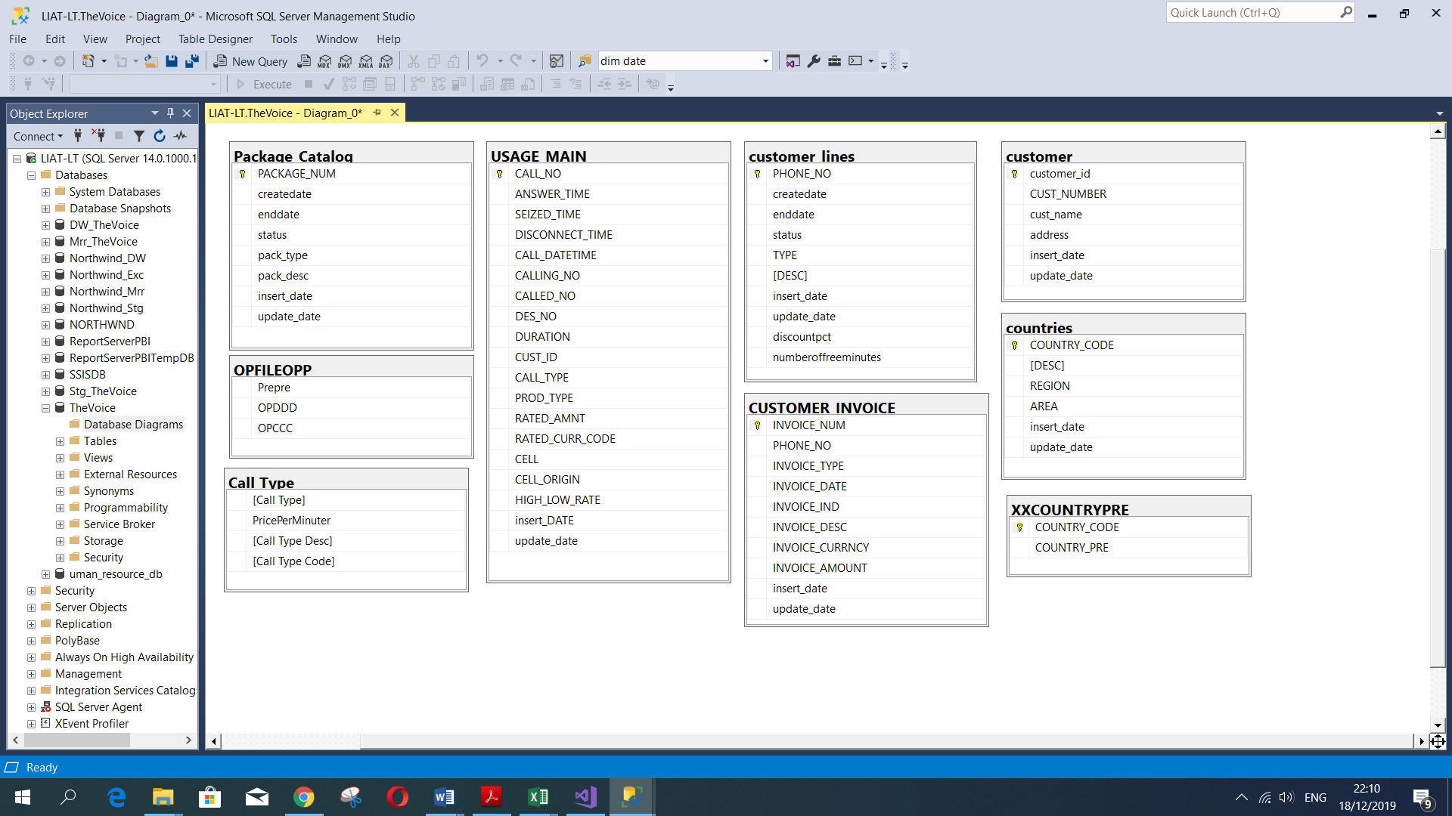The company database ‘The Voice’ that we received contains 7 operational tables as an SQL script and 2 CSV files tables. In this stage, we start the ETL process and analyzing our operational data.

**Loop**

In order to be able to filter and present nicely over a period of time the analysis tools, we enlarge the Usage_main table by adding rows. We managed to do it automatically by writing a dedicated Loop in T-SQL language.

The Loop Based on 'While' loop that gets an N variable of a number of rows we would like to add. Each column of the Usage_main table gets a variable that gets a different parameter on each iteration. Some of the variables are determined randomly by functions like dates and times, some are determined by subquery which compares to other tables in order to keep the data reliability and some are calculated like duration.

. (**See ***Loop*** attached file).

**SSIS -And ETL Process**

Planning an ETL process in a project is a very important step for the project to succeed.

The skills that we gained during our studies, helped overcome any issues that may arise in the ETL process right at the beginning of the project.

This ETL process map and design: Mirror, Stage and Data Warehouse. A Data Warehouse splits into two parts: dimensions and fact.

For the ETL process to be correct, the process must be applied according to the conventional methodology.

1. A complete "data cleansing " process.

2. The ETL process should work daily by the "Job" command built into the SSMS software after the ETL process completed.

We start in The Mrr stage and create the Mrr_Call_Type table and OPFILEOPP table that we received as CSV files. we continue to transforming, data cleansing, and handling NULL in the Stg stage. After modeling our data, we continue to build the data warehouse.

**5.1 ETL Process– Step 1 - Dynamically upload CSV files:**

In order to create a dynamic upload of CSV files, we required to Create variables, editing the Connection Manager and Data Types For loading the data successfully.

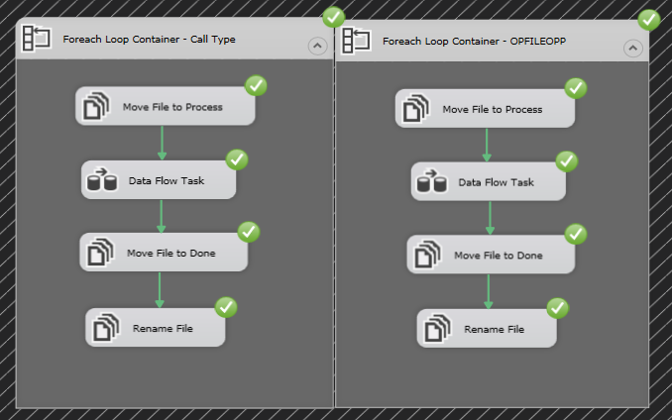

The result :

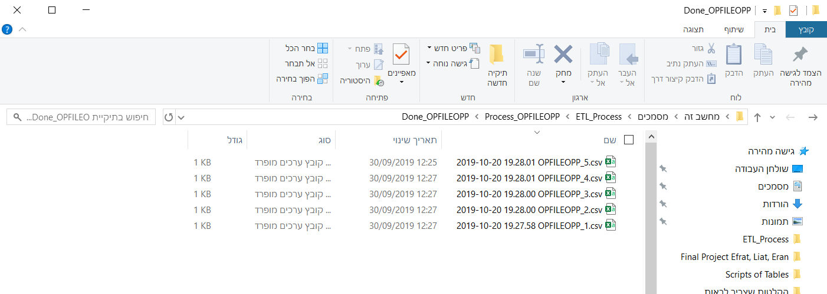OPFILEOPP

Call_Type

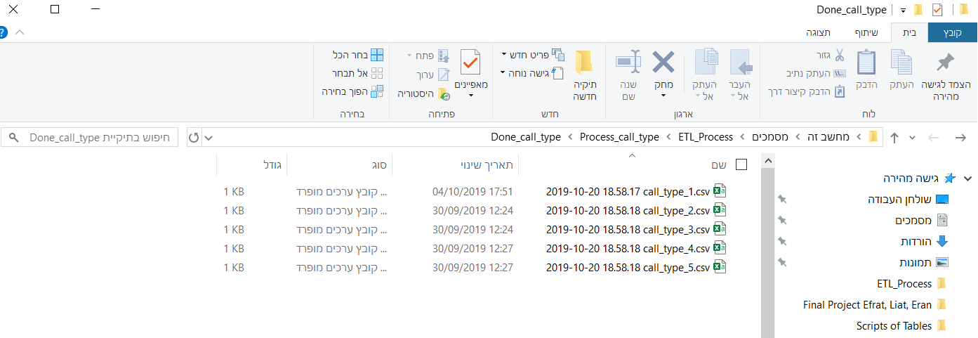

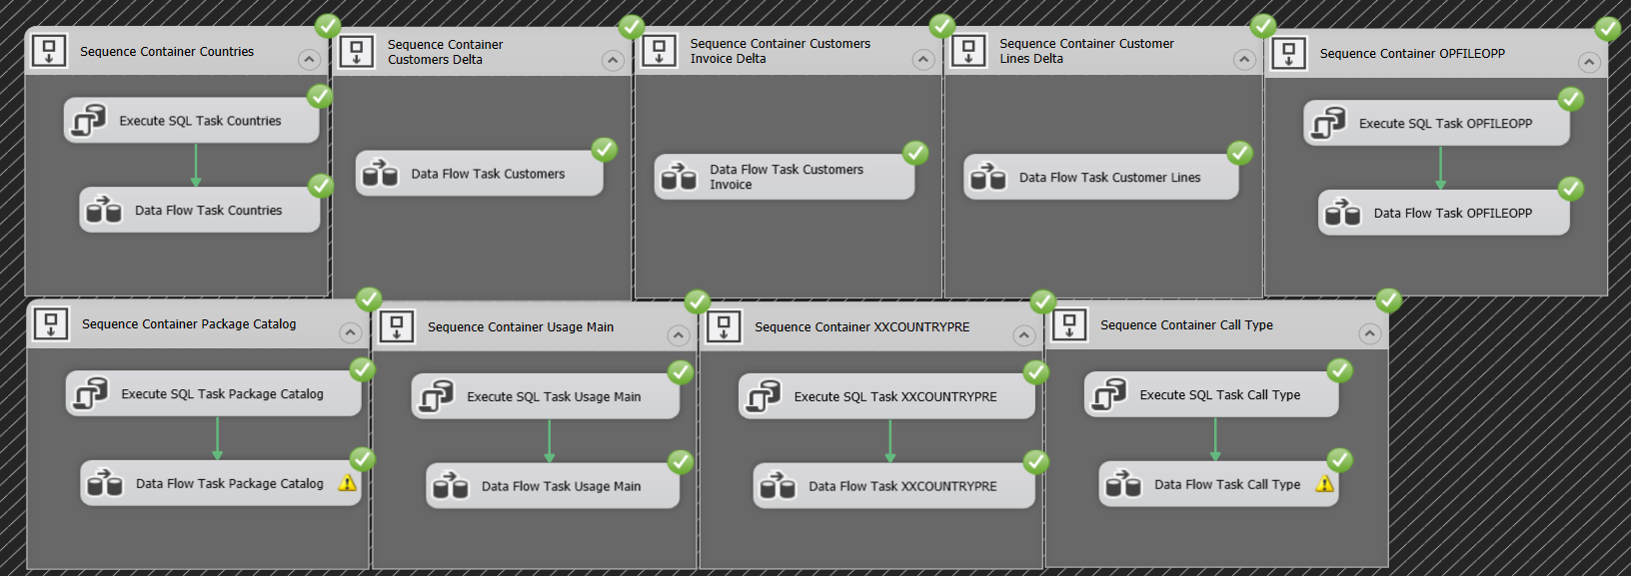**5.2 ETL Process– Step 2 – Operational to Mirror:**

At this point, the goal is to duplicate the data from the operational tables, with only small changes.We display two ways at each ETL process in this step:

1. the data will transfer only delta (diff), in three of the tables (Customers, Customers Invoice and Customer Lines). This process is faster because only new data will be

transferred.

1. The second option is to perform a full transfer and truncate every time the process is started. This process affects the performances of the servers.

See Customers Table Only Delta for exsemple:

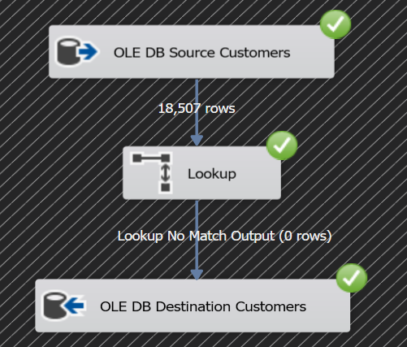

in the Mrr stage, we chose to import an Excel table into the mirror stage called ‘Region Prefix’. in order to handle with countries with the same pre-code. And avoid errors in the dimension step.

**5.3 Uploading Excel to SSMS Region Prefix Table** :

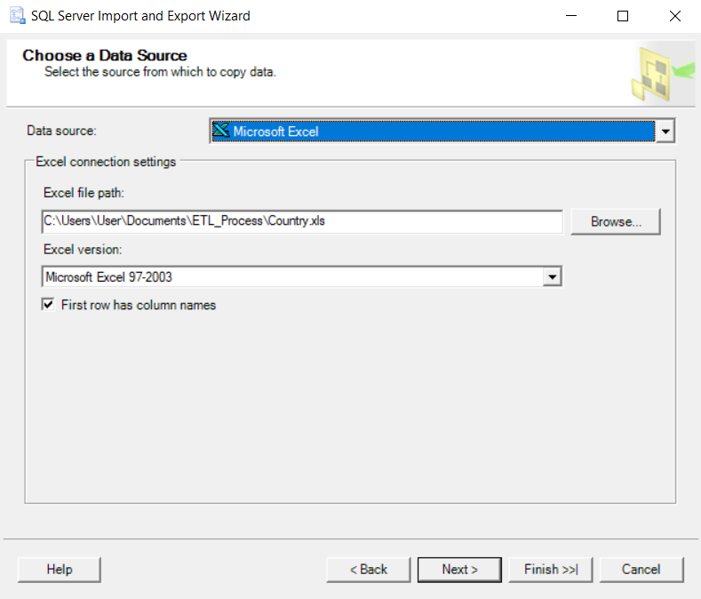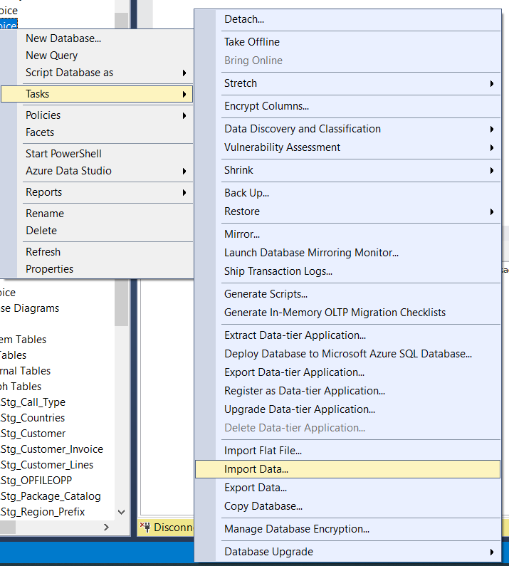1. 2.

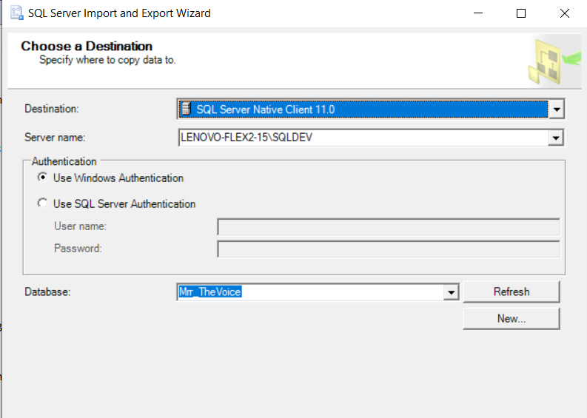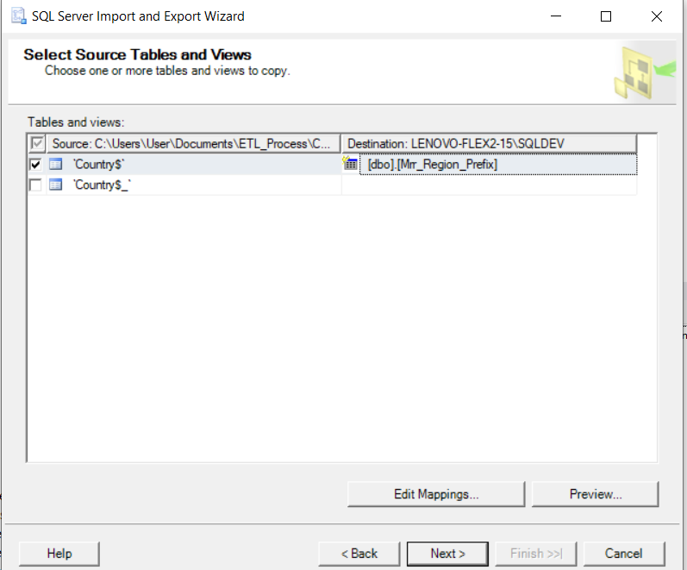3. 4.

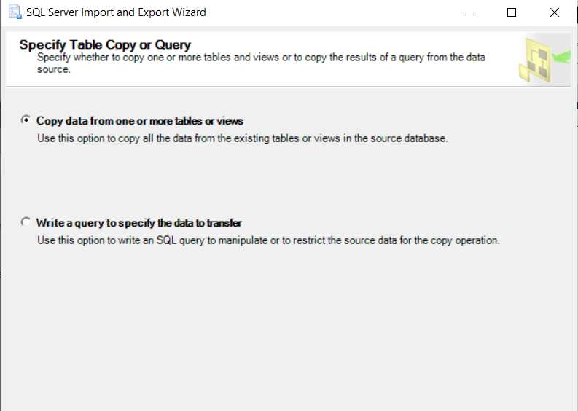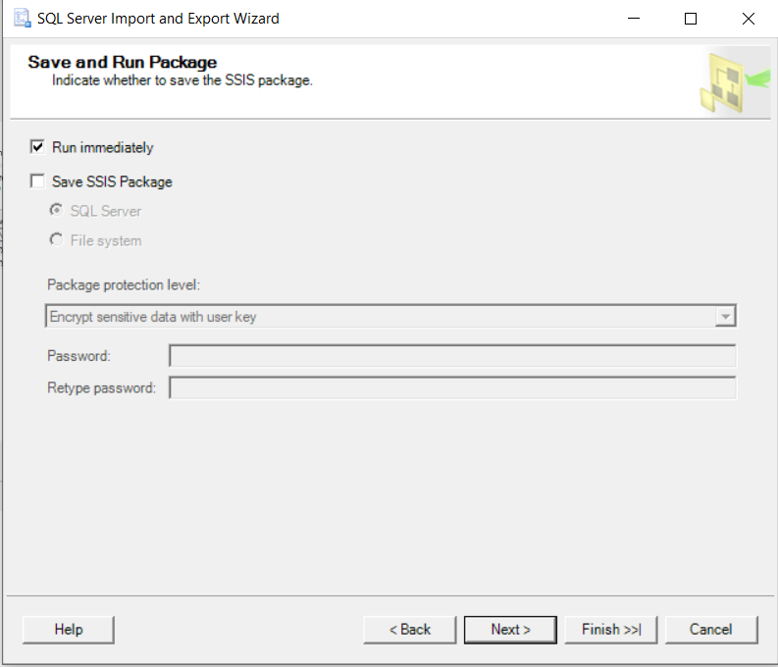5.6.

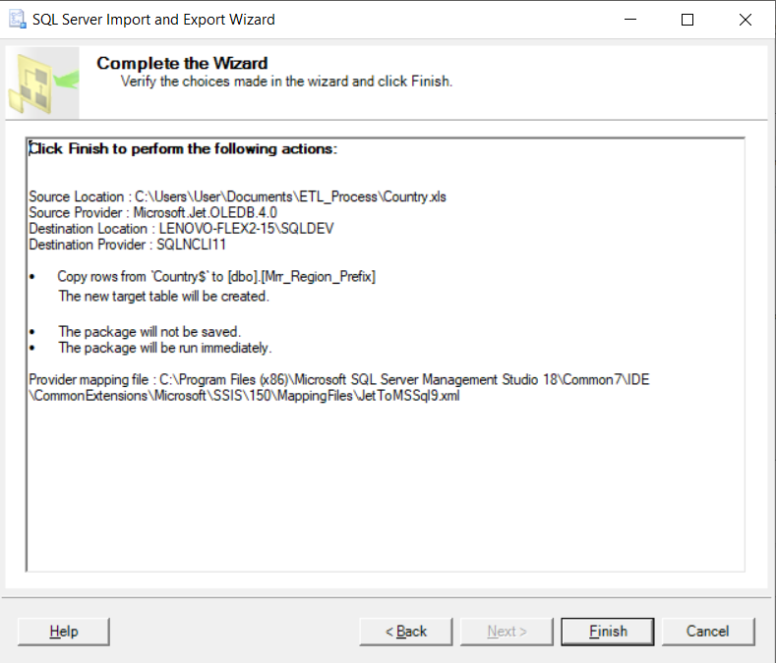7.

**5.4 ETL Process– Step 3 - Mirror to Stage:**

At this stage of the ETL process, we selected to do the Truncate process for all tables.

The most important part of this step is handling the "Null" values and "Errors handling".

In this stage we added calculated columns in "SSIS Expression" language and "SQL Commend".

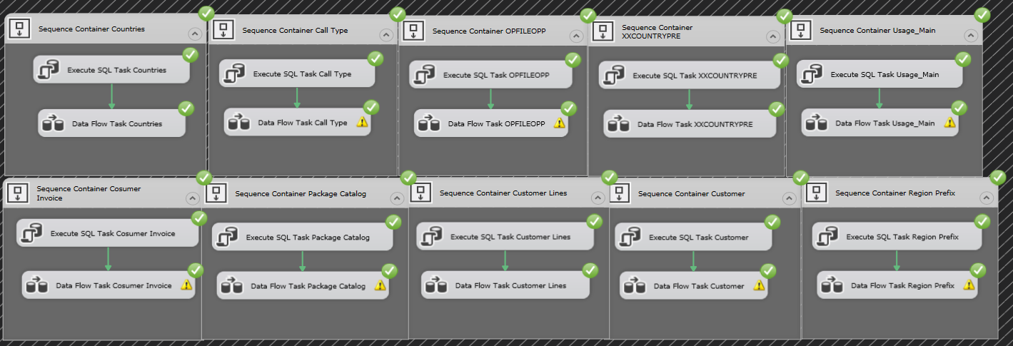

See Usage Main Table For example in error handling:

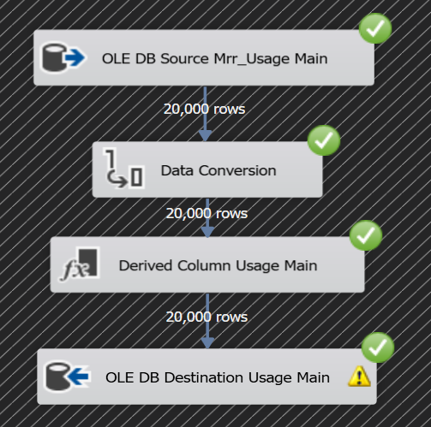

**5.5 Error Handling:**

In the "Usage Main" Table we can see how we handled the "Null" values and handle errors. there are three options for error handling.

1. Character Field Data – for example here – 'Calling Number'

way of treatment – write "SSIS Expression" with Boolean conditions.

*“ISNULL([Calling Number]) ? "Unknown" : [Calling Number]”*

1. Numerical Data - for example here – 'Duration'

way of treatment – write "SSIS Expression" with Boolean conditions.

*“ISNULL(Duration)? -1: Duration”*

1. Data Dates - for example here – 'Seized Date'

way of treatment – write "SSIS Expression" with Boolean conditions.

*“ ISNULL([Seized Date]) ? (DT_DBDATE)"1900-01-01" : [Seized Dat”*

These are the SQL commands we used in five of the tables in the OLE DB source.

Using SQL commands will help us in the data transition from Stg to DW.

--Mrr_OPFILEOPP

select Distinct*

from [dbo].[Mrr_OPFILEOPP]

--Mrr_Call_Type

select distinct *

from [dbo].[Mrr_Call_Type]

--Mrr_Customer

select *

from

(select *, right(CUST_NUMBER,7) 'Number', case when CUST_NUMBER like '+___%' then SUBSTRING(CUST_NUMBER,2,3) end 'Prefix country',

case when CUST_NUMBER like '+___%' then SUBSTRING(CUST_NUMBER,5,2) end 'Prefix Operation'

from Mrr_Customer

where CUST_NUMBER like '+972%'

Union all

select *, right(CUST_NUMBER,7) 'Number', case when CUST_NUMBER like '+_%' then SUBSTRING(CUST_NUMBER,2,1) end 'Prefix country',

case when CUST_NUMBER like '+_%' then SUBSTRING(CUST_NUMBER,3,3) end 'Prefix Operation'

from Mrr_Customer C

where CUST_NUMBER like '+1%') tab

order by customer_id

--Mrr_Customer_Invoice

select *, right(PHONE_NO,7) 'Number', case when PHONE_NO like '+___%' then SUBSTRING(PHONE_NO,2,3) end 'Prefix country', case when PHONE_NO like '+___%' then SUBSTRING(PHONE_NO,5,2) end 'Prefix Operation'

from Mrr_Customer_Invoice

order by INVOICE_NUM

--Mrr_Customer_Lines

select *, right(PHONE_NO,7) 'Number', case when PHONE_NO like '+___%' then SUBSTRING(PHONE_NO,2,3) end 'Prefix country', case when PHONE_NO like '+___%' then SUBSTRING(PHONE_NO,5,2) end 'Prefix Operation'

from Mrr_Customer_Lines

where PHONE_NO like '+972%'

Union all

select *, right(PHONE_NO,7) 'Number', case when PHONE_NO like '+_%' then SUBSTRING(PHONE_NO,2,1) end 'Prefix country',

case when PHONE_NO like '+_%' then SUBSTRING(PHONE_NO,3,3) end 'Prefix Operation'

from Mrr_Customer_Lines

where PHONE_NO like '+1%'

--Mrr_Usage_Main

select *

from

(select CALL_NO as [Call Number], CUST_ID as [Customer ID], CALLING_NO as [Calling Number], right(CALLING_NO,7) as [C_Number], case when CALLING_NO like '+___%' then SUBSTRING(CALLING_NO,2,3) end [Calling Country Prefix], case when CALLING_NO like '+___%' then SUBSTRING(CALLING_NO,5,2) end [Calling Prefix Operation], ANSWER_TIME as [Answer Time], convert(date,SEIZED_TIME) as [Seized Date], convert(time,(convert(smalldatetime,SEIZED_TIME))) as [Seized Time], DISCONNECT_TIME as [Disconnect Time], DURATION as [Duration], DES_NO as [Destination Number], right(DES_NO,7) as [D_Number], case when DES_NO like '+___%' then SUBSTRING(DES_NO,2,3) end [Destination Country Prefix], case when DES_NO like '+___%' then SUBSTRING(DES_NO,5,2) end [Destination Prefix Operation], CALL_TYPE as [Call Type], PROD_TYPE as [Call Type Descripion], RATED_AMNT as [Call Rank], RATED_CURR_CODE as [Currency], CELL as [Cell], CELL_ORIGIN as [Cell Origin], HIGH_LOW_RATE as [High or Low Time Rating], convert(date,CALL_DATETIME) as [Call Date]

from Mrr_Usage_Main

where CALLING_NO like '+972%' and DES_NO like '+972%'

union all

select CALL_NO as [Call Number], CUST_ID as [Customer ID], CALLING_NO as [Calling Number], right(CALLING_NO,7) as [C_Number], case when CALLING_NO like '+_%' then SUBSTRING(CALLING_NO,2,1) end [Calling Country Prefix], case when CALLING_NO like '+_%' then SUBSTRING(CALLING_NO,3,3) end [Calling Prefix Operation], ANSWER_TIME as [Answer Time], convert(date,SEIZED_TIME) as [Seized Date], convert(time,(convert(smalldatetime,SEIZED_TIME))) as [Seized Time], DISCONNECT_TIME as [Disconnect Time], DURATION as [Duration], DES_NO as [Destination Number], right(DES_NO,7) as [D_Number], case when DES_NO like '+___%' then SUBSTRING(DES_NO,2,3) end [Destination Country Prefix], case when DES_NO like '+___%' then SUBSTRING(DES_NO,5,2) end [Destination Prefix Operation], CALL_TYPE as [Call Type], PROD_TYPE as [Call Type Descripion], RATED_AMNT as [Call Rank], RATED_CURR_CODE as [Currency], CELL as [Cell], CELL_ORIGIN as [Cell Origin], HIGH_LOW_RATE as [High or Low Time Rating], convert(date,CALL_DATETIME) as [Call Date]

from Mrr_Usage_Main

where CALLING_NO like '+1%' and DES_NO like '+972%'

union all

select CALL_NO as [Call Number], CUST_ID as [Customer ID], CALLING_NO as [Calling Number], right(CALLING_NO,7) as [C_Number], case when CALLING_NO like '+___%' then SUBSTRING(CALLING_NO,2,3) end [Calling Country Prefix], case when CALLING_NO like '+___%' then SUBSTRING(CALLING_NO,5,2) end [Calling Prefix Operation], ANSWER_TIME as [Answer Time], convert(date,SEIZED_TIME) as [Seized Date], convert(time,(convert(smalldatetime,SEIZED_TIME))) as [Seized Time], DISCONNECT_TIME as [Disconnect Time], DURATION as [Duration], DES_NO as [Destination Number], right(DES_NO,7) as [D_Number], case when DES_NO like '+_%' then SUBSTRING(DES_NO,2,1) end [Destination Country Prefix], case when DES_NO like '+_%' then SUBSTRING(DES_NO,3,3) end [Destination Prefix Operation], CALL_TYPE as [Call Type], PROD_TYPE as [Call Type Descripion], RATED_AMNT as [Call Rank], RATED_CURR_CODE as [Currency], CELL as [Cell], CELL_ORIGIN as [Cell Origin], HIGH_LOW_RATE as [High or Low Time Rating], convert(date,CALL_DATETIME) as [Call Date]

from Mrr_Usage_Main

where CALLING_NO like '+972%' and DES_NO like '+1%'

union all

select CALL_NO as [Call Number], CUST_ID as [Customer ID], CALLING_NO as [Calling Number], right(CALLING_NO,7) as [C_Number], case when CALLING_NO like '+_%' then SUBSTRING(CALLING_NO,2,1) end [Calling Country Prefix], case when CALLING_NO like '+_%' then SUBSTRING(CALLING_NO,3,3) end [Calling Prefix Operation], ANSWER_TIME as [Answer Time], convert(date,SEIZED_TIME) as [Seized Date], convert(time,(convert(smalldatetime,SEIZED_TIME))) as [Seized Time], DISCONNECT_TIME as [Disconnect Time], DURATION as [Duration], DES_NO as [Destination Number], right(DES_NO,7) as [D_Number], case when DES_NO like '+_%' then SUBSTRING(DES_NO,2,1) end [Destination Country Prefix], case when DES_NO like '+_%' then SUBSTRING(DES_NO,3,3) end [Destination Prefix Operation], CALL_TYPE as [Call Type], PROD_TYPE as [Call Type Descripion], RATED_AMNT as [Call Rank], RATED_CURR_CODE as [Currency], CELL as [Cell], CELL_ORIGIN as [Cell Origin], HIGH_LOW_RATE as [High or Low Time Rating], convert(date,CALL_DATETIME) as [Call Date]

from Mrr_Usage_Main

where CALLING_NO like '+1%' and DES_NO like '+1%') tab

order by [Call Number]

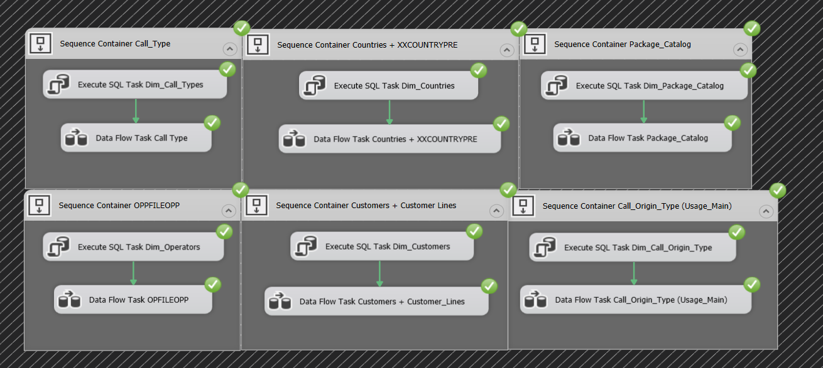**5.6 Process ETL – Step 4 - Stage to DW - Dimension:**

In the Dimension stage, we decided how to connect the tables.

* For example, in table Dim_Countries, We've added from "SSIS Toolbox" Option under Common Categories - Sort. In these tables, we sort by country name, and 189 rows passed with data from both tables.

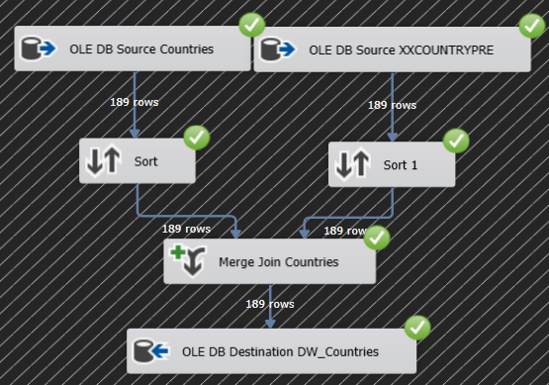

* In the Customers table, we chose to split the customers into two- “Israeli" customers and customers from the "Rest of the world".

First, we connected the "customers" table to the table "OPFILEOPP", and Sort the data by the "Prefix Operation" column, and then we performed the "Merge Join" operation.

after connecting the two tables we had to connect the "XXCOUNTRTPRE" table. This time, we sorted the data with the column "Country Prefix" and we did the same thing in "Merge Join" and now we have taken the column "Country".

We can see that 9,999 rows are passed. these are "Israeli" customers.

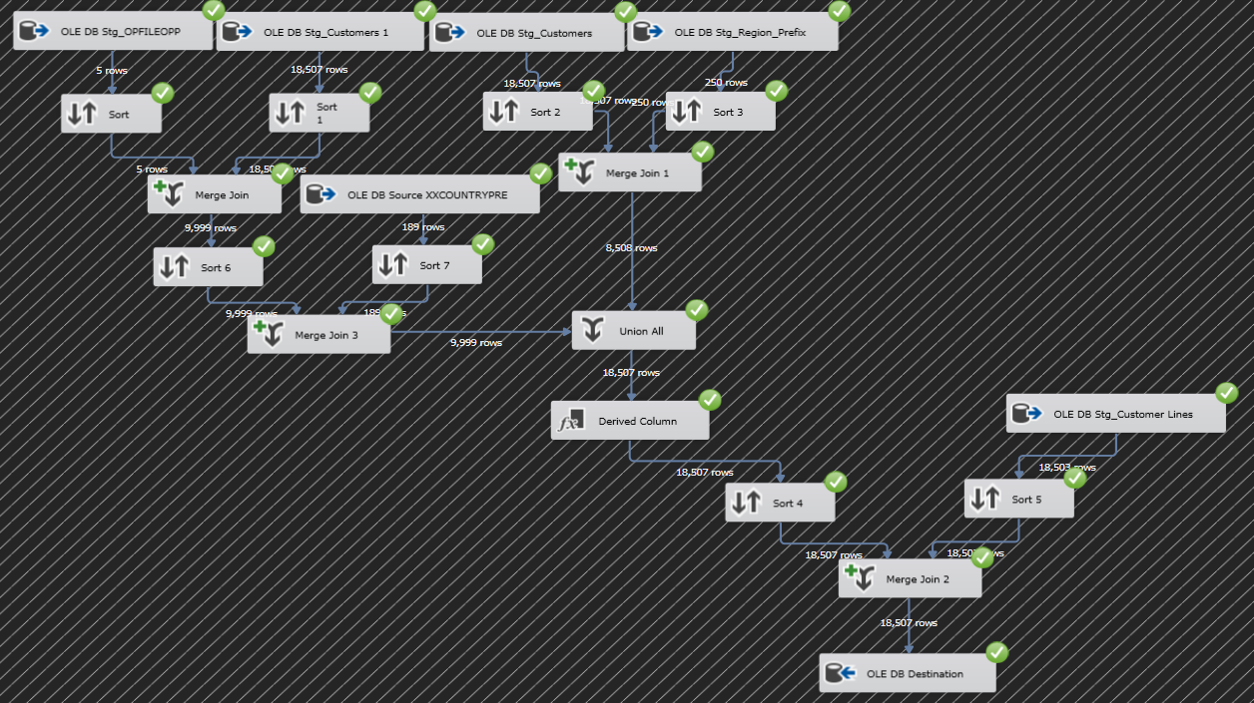Now, we will refer to the "Rest of the World" customers. we linked the "Customers" table to the "Region_Prefix" table that we create in the "Mirror" stage Because each area has its own prefix. After that, we performed "Merge Join" and we connect the country name. We can see that 8,508 rows are passed. these are " Rest of the World " customers.we made a connection of all customers with option "Union All" that Found in the "SSIS Toolbox", and we make 18,507 of Customers, this figure is featured in the following image. We can also see another connection between the tables that we created the Customers table to "Costumer_lines" table in order to produce the end of the process "Dim_Costumers".The sort has been done between "Phone Number" from "Costumer_lines" and "Customer Number" Of all the connections made on the left side.

**5.7 ETL Process– Step 5 - Stage to DW – Fact**

We have decided to split the fact process into two. Origin and Destination.

We've taken the "Usage_Main" table and the "Customer_Lines" table and sort the data with "Calling Number" and "Phone Number". In Merge Join we merged the data with the same columns. Next, we begin to connect the data with the dimensions We have already created in the previous step.

In "Lookup Dim_Customers" we choose to "Redirect rows to no match output" Because we want the data to be entered without a match.

Within the Lookup, under the "Columns" definition we connect "Calling Number" and "Customers Number" and connect the "Dim_Costumers" table with two columns- "Customers ID" and "Country".

Next, we connect the "Dim_Countries" table, and we choose again "Redirect rows to no match output".

Within the Lookup under the "Columns" definition we connect "Calling Country Prefix" and "Country" We pulled this column from the "Dim_Customers" table, and connect it with "Dim_Countries" table, the column "Key Country".

in order for data to be matched to the Fact table, we need to use the process at "Data Conversion" from "SSIS Toolbox":

We changed the data type to columns "Calling Prefix Operation", "Calling Country Prefix" to A four-byte, signed integer [DT_I4] data type.

"Seized Date" to date structure that consists of year, month, and day [DT_DBDATE].

and "Seized Time" to time structure that consists of the hour, minute, second, and fractional seconds. The fractional seconds have a maximum scale of 7 digits [DT_DBTIME2].

Next, we chose to get the derived column to avoid "Null" values (error handling), Because prefix 212 does not belong to any operator.

ISNULL([Key Mobile Prefix]) ? -1 : [Key Mobile Prefix].

Next, We are sorting (4 and 5) by "Merge Join. Customer ID" 🡪 Merge Join 1.Customer ID and Call Number 🡪 Call Number.

After the sorting, we do "Merge Join 2" And connects the same data from the sorting stage.

We take all of the columns from both sides, Origin, and Destination.

Next, in "Lookup Dim_Call_Types" we are connected between column "Call Type" 🡪 "Call Type Code" and we take the columns from Lookup "Key Call Type" and "Price Per Minute".

In the "Price Per Minute" column, we took the next step of column calculation.

In "Lookup Dim_Package_Catalog" we connected the columns "Package Type" and the "Package Number" column.

Next, in "Lookup Dim_Call_Origin_Type" we connected between the column

"Key Source Cell" = "Cell Origin" and took the "Key Source Cell" column.

In "Lookup Dim_Date" After we created this dimension in SSMS with a script "Calander_Table" 🡪 "Dim_Date" we connected between column "Key Date" = "Seized Date" and took "Key Date" column.

In "Lookup Dim_Time" After we created this dimension in SSMS with a script,

"dbo.Time" 🡪 "Dim_Time" we connected between column "Key Time" = "Seized Time" and we took "Key Time" column.

This the result:

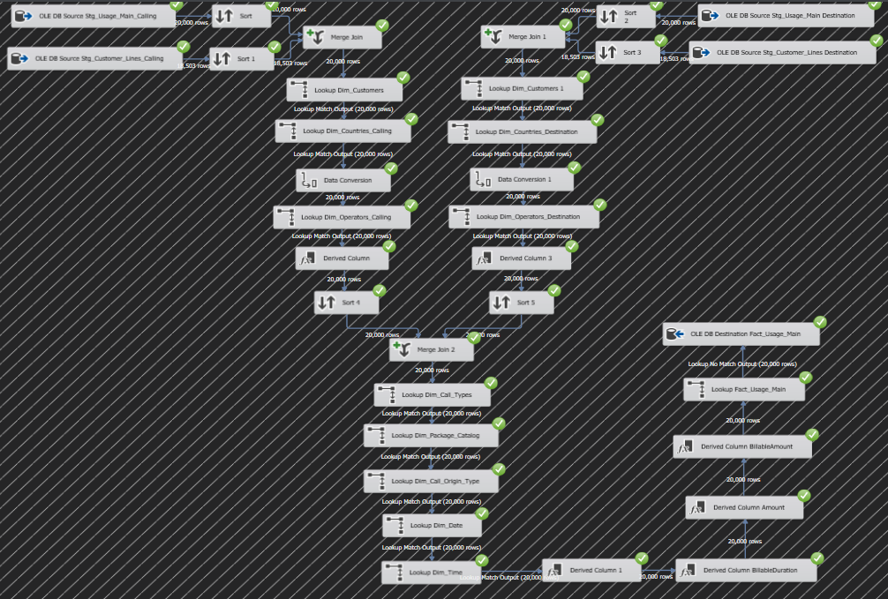

**5.8 Deployment and Catalog:**

Before deploying the ETL process, an "Integration Services Catalog" must be produced in SSMS.

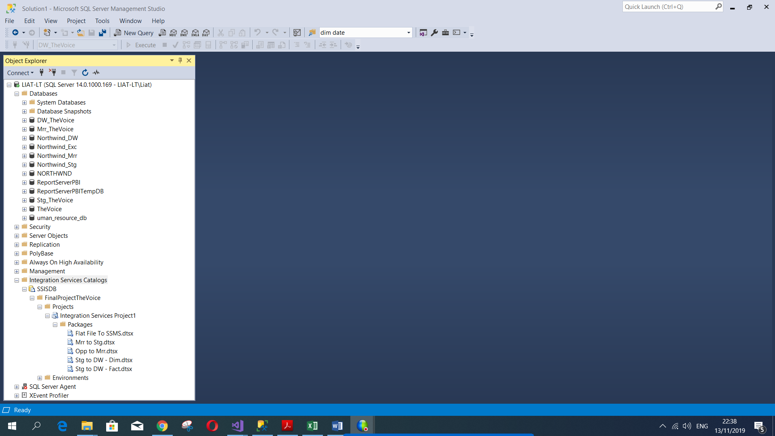

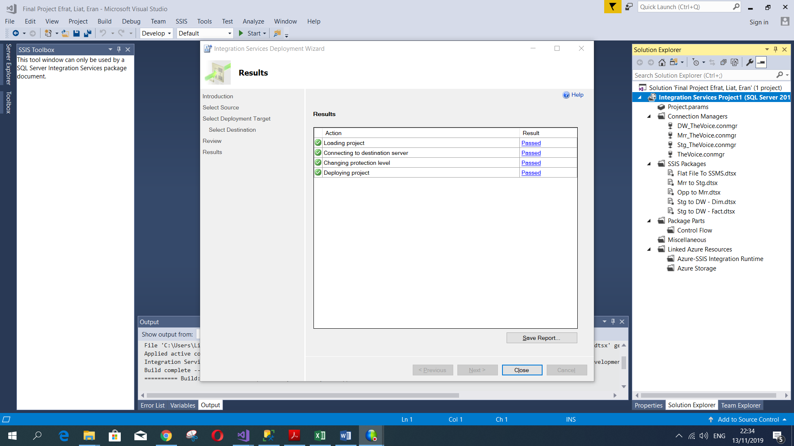

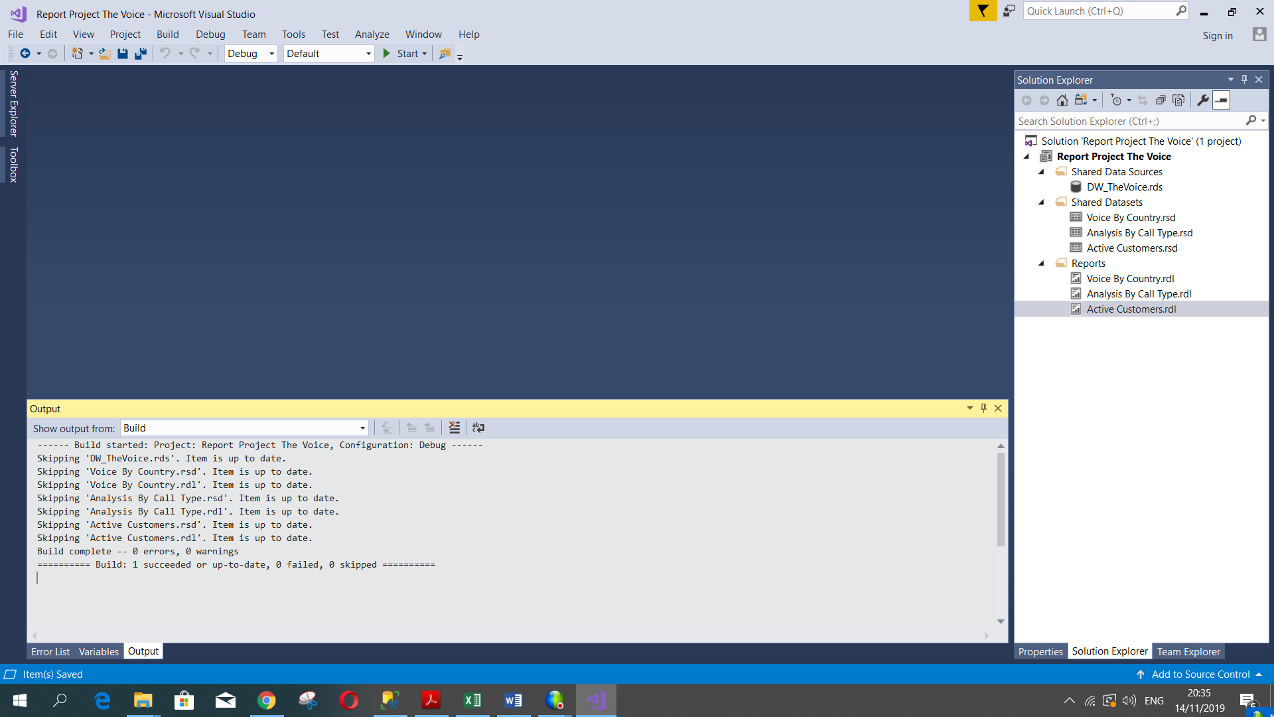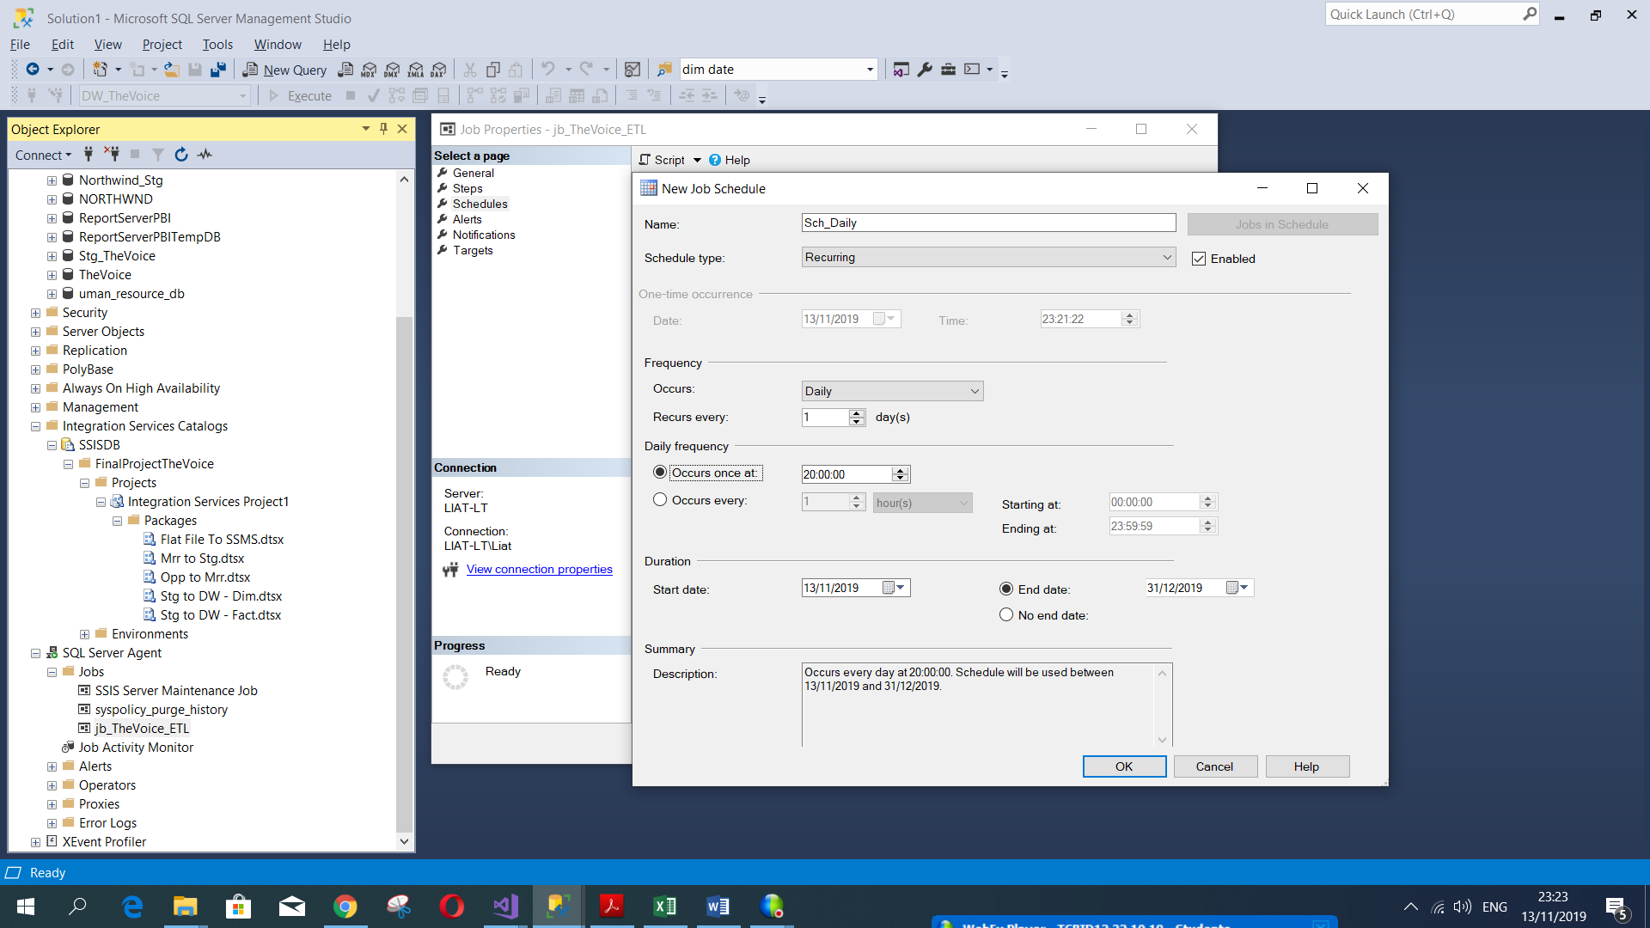**5.9 Job and Schedules in SSMS for SSIS Packages (script included) Deploy from SSRS:**

**See ***Script Job*** script.

**SSRS**

First, we establish a Power BI Report Server and full configuration.

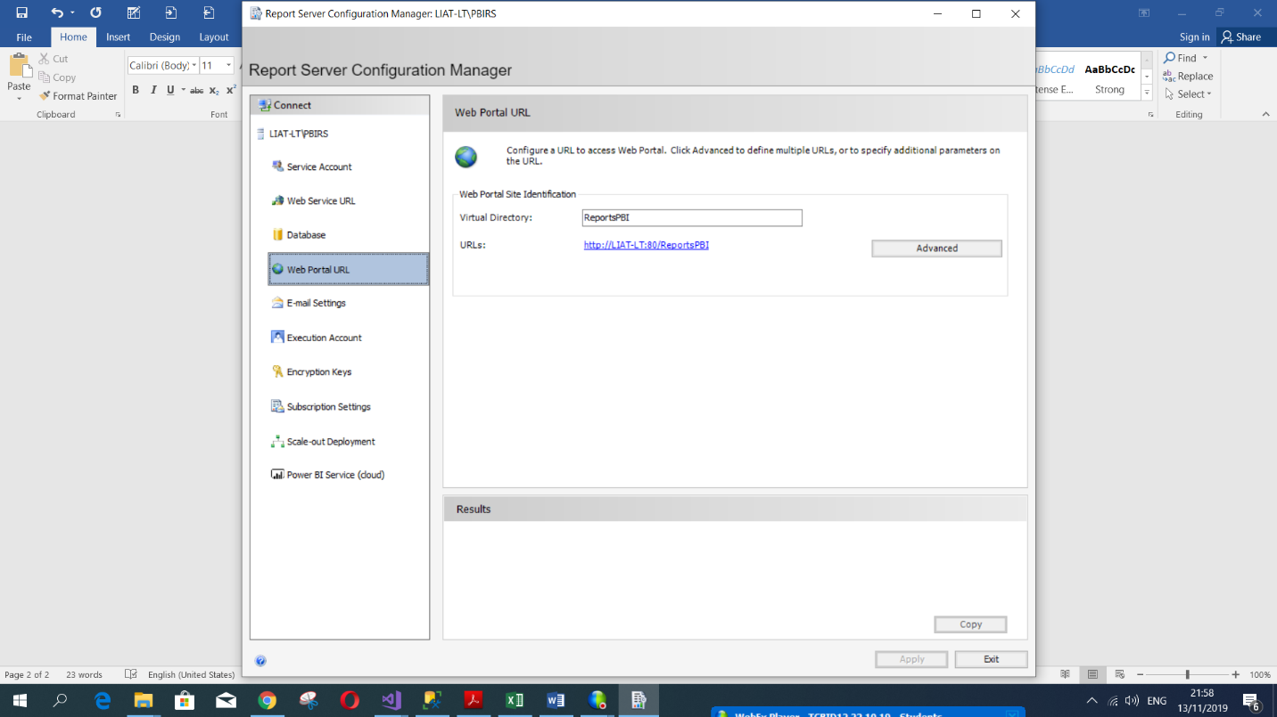Power BI Report Server – URL

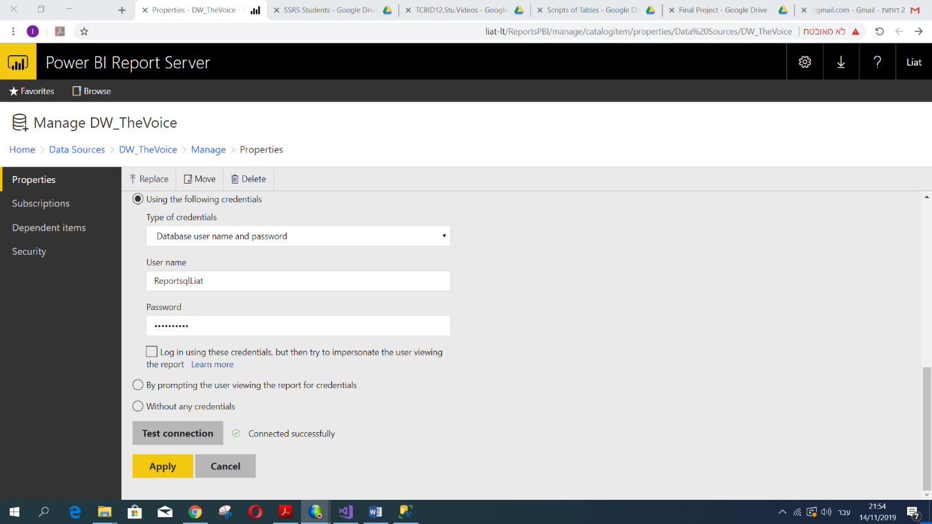Report server security - role in folder + inherited & customize

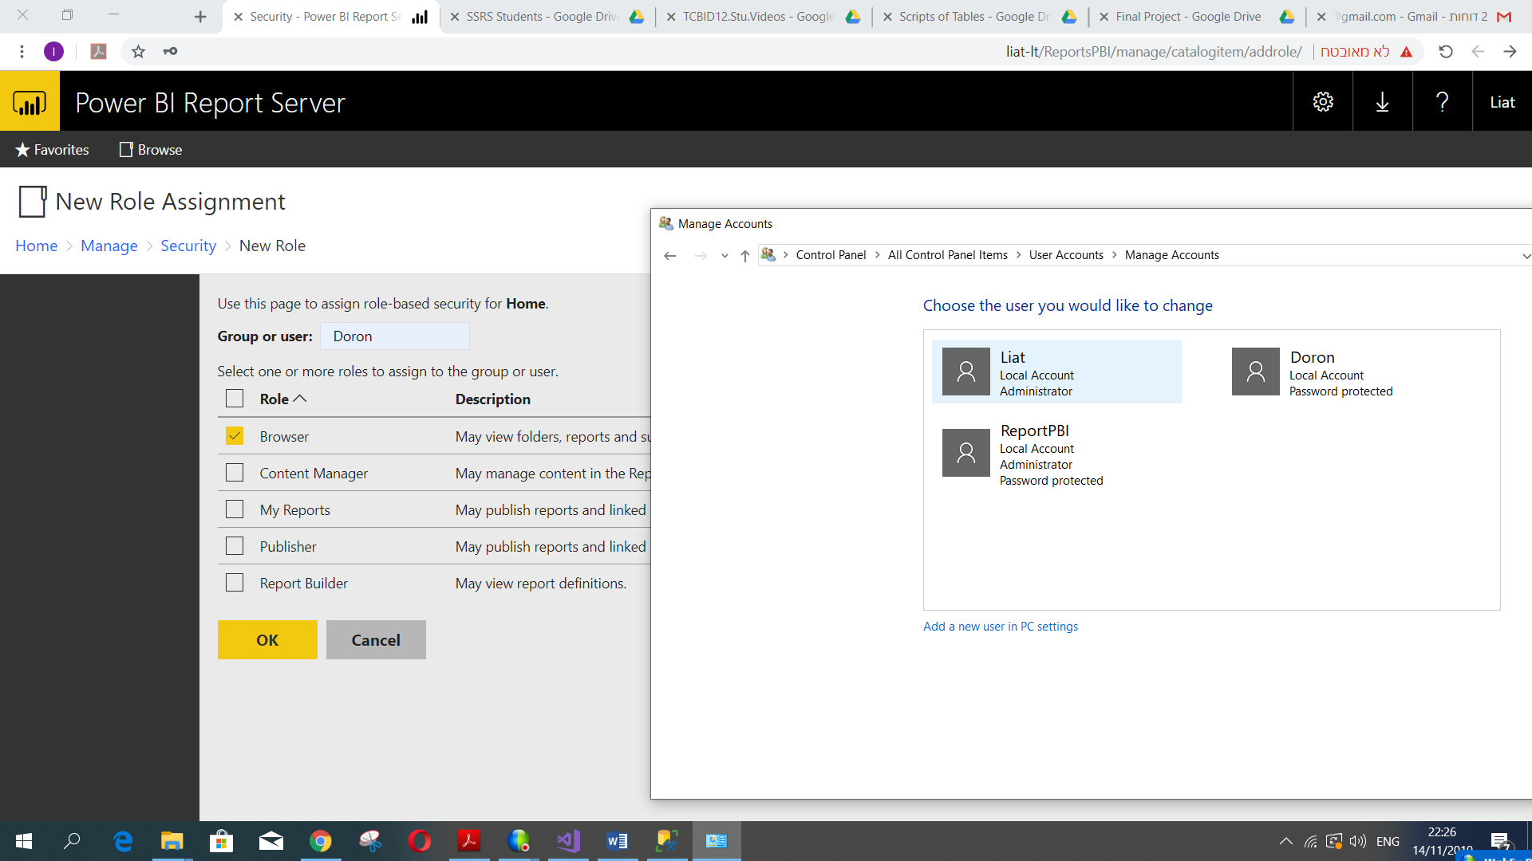Report Server Security- Role to a new user: Doron (not admin)

**6.1 SSRS Reports**

* The first report displays the amount of active and inactive customers at any given time, based on the start and end parameters of the date we entered in "Shared Datasets" in SQL language.

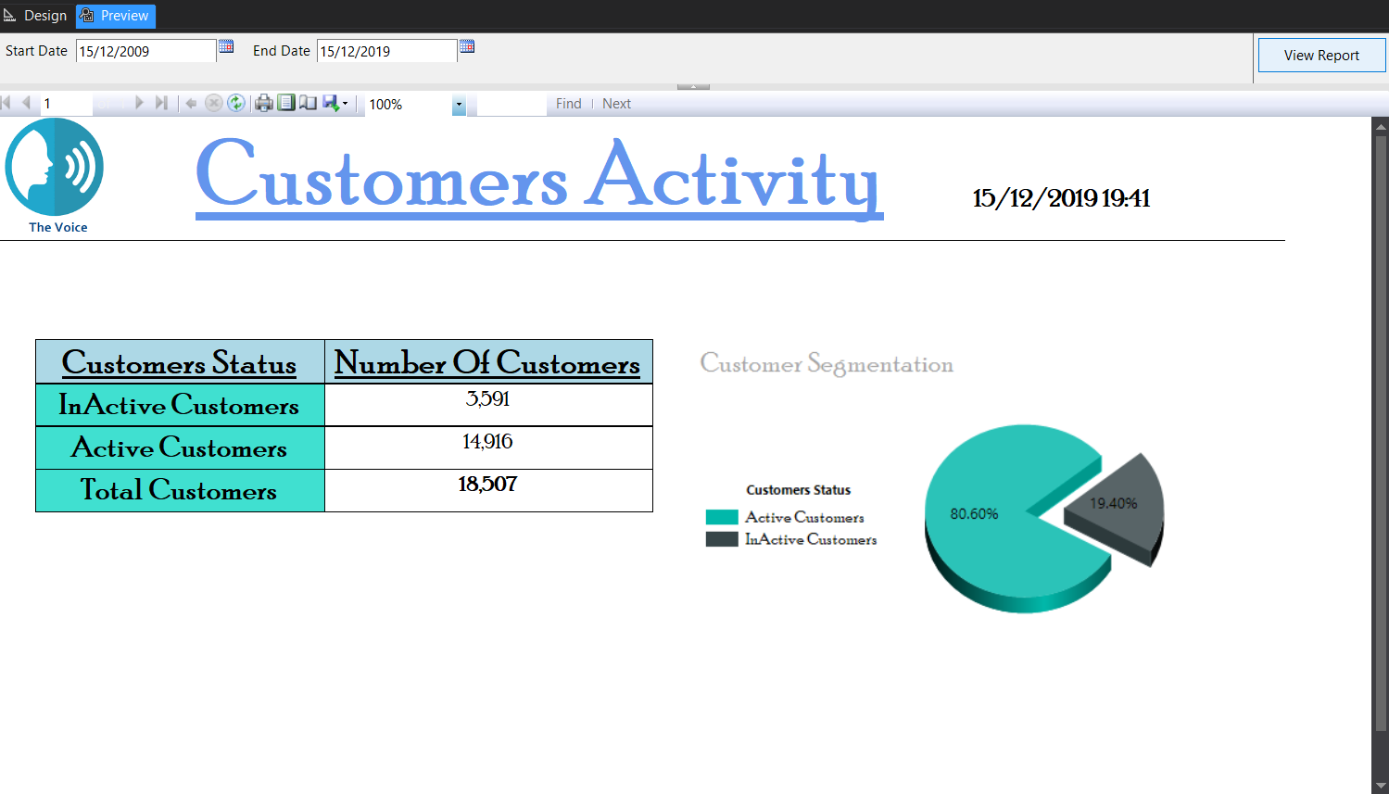

* The second report shows us the number of sources used (Origin Usage, Voice, Massage and Data) by each country, operator, and customers. In this report, we used to toggled on country and operator columns. And add filters by country name and date. In this report, we used to toggled on country and operator columns. In addition, we chose to show the number of uses by the operators with a pie chart. There are filters by country, name, and date.

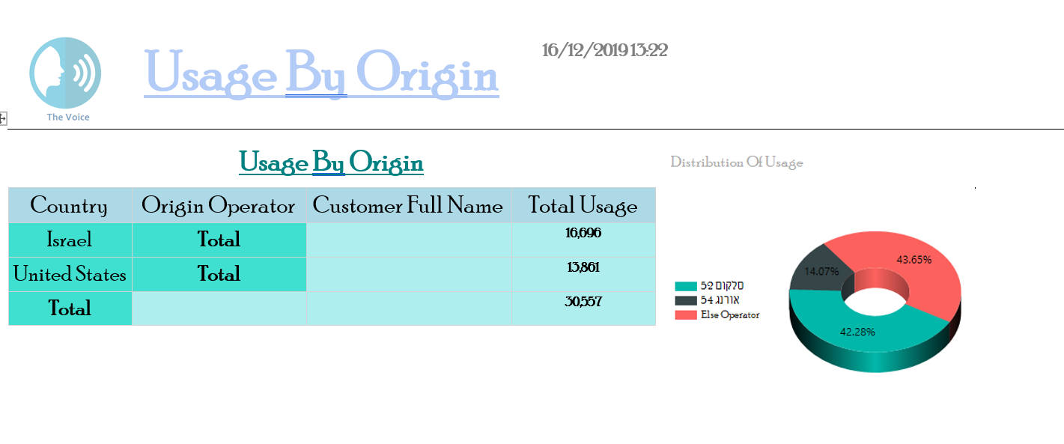

* 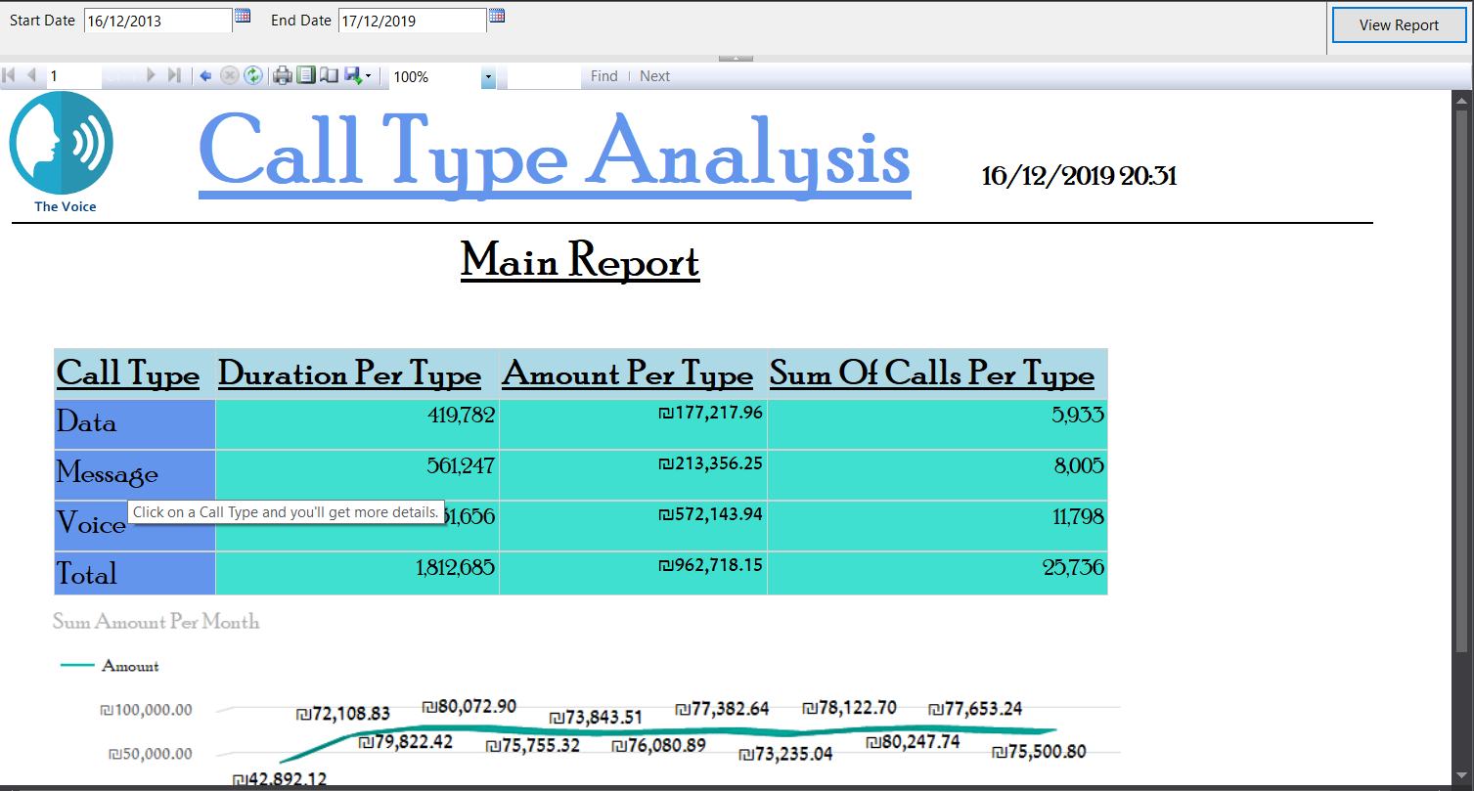The third report shows the call types, the amount of duration, the amounts of money and the total of use by data type. In this report, we implemented Drill-through visualization.

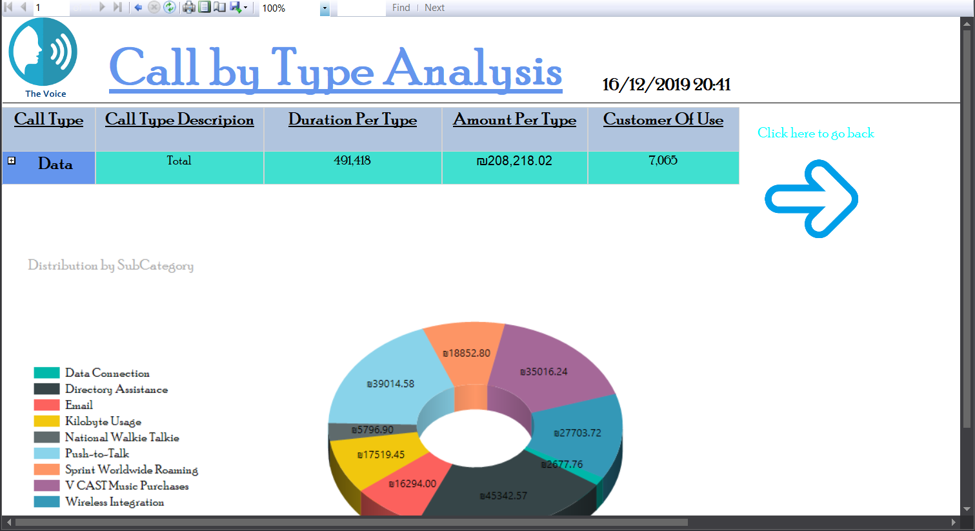

After the reports are prepared, a report server must be produced by "Report Server Configuration Manager".

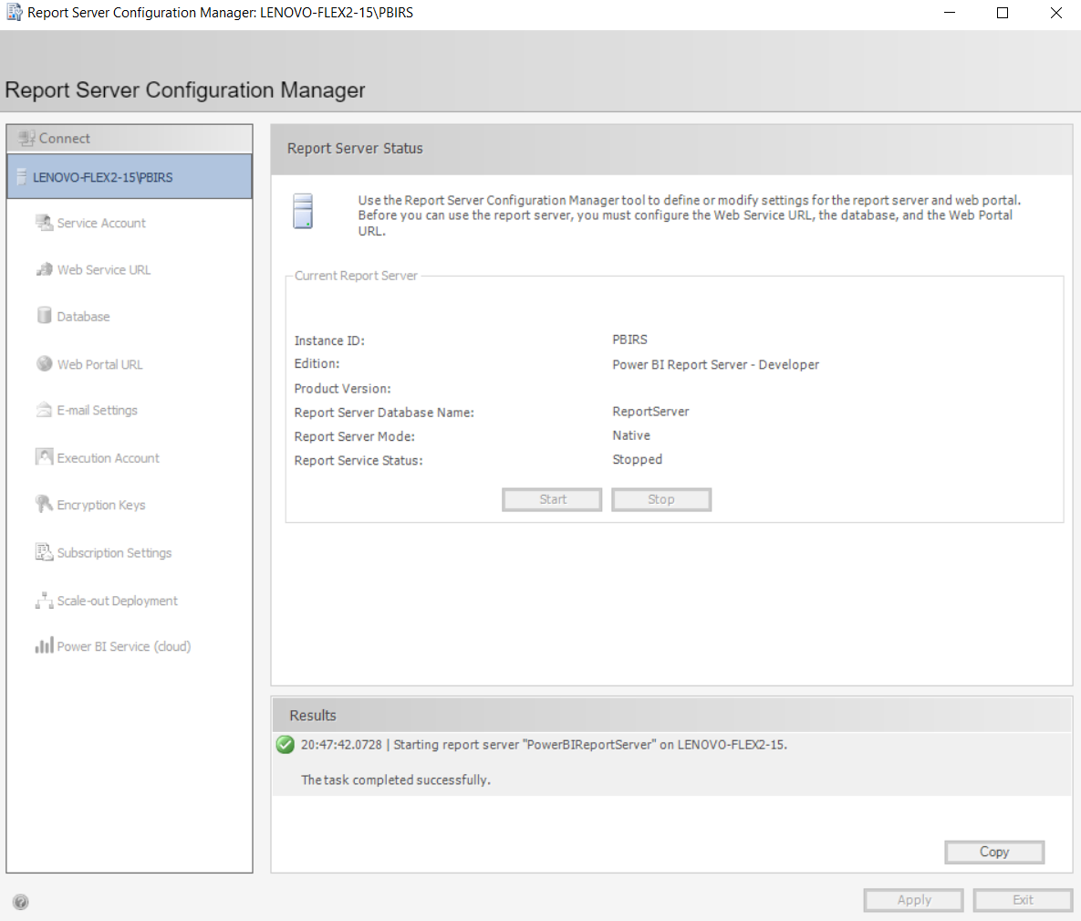

SSRS deployment process, to Power BI Report Server

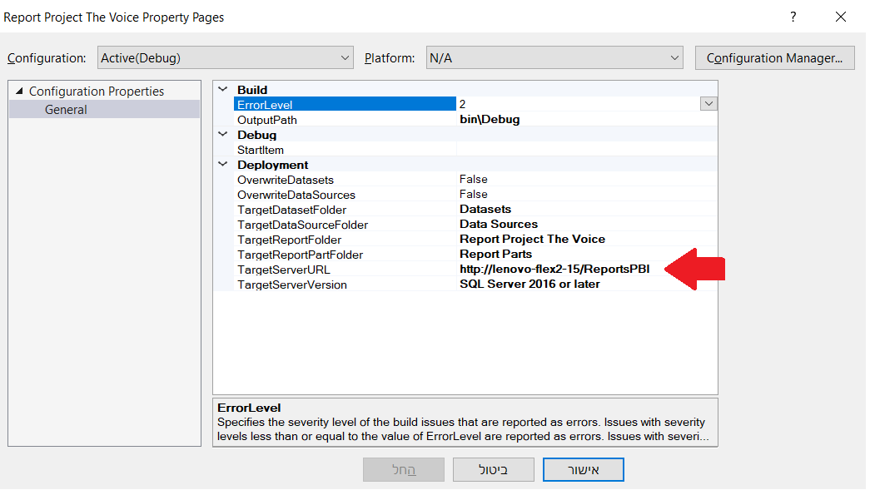

**Tabular Model**

In this part of the project, we created a tabular model that gives the end-user of the BI system quick access for all the business-relevant data.

The tabular model is also been created in the SSDT developing tool, in a new project under analysis service – tabular.

Our first step was to create a new DW_TheVoise in SQL Server which supports the analysis service, so we configured a new server and we run again all of the ETL processes on SSIS with Different connect manager, which connected to our new server.

In the new tabular project we just opened, we connected to our new DW and started to develop the model following the next steps:

* In order to create a semantic layer, we renamed the tables and the column so it will fit the end-user in order to understand and represent.
* We mark our Date table, as a Date table in Table(ut).
* In the diagram view, we defined the relationship between the tables by connecting between the keys and also build hierarchies.

In order to overcome the problem that we had to create to connections (source and destination) at the same table (at two tables), we doubled the Countries end the Operators tables and turned them into destination countries and destination operators.

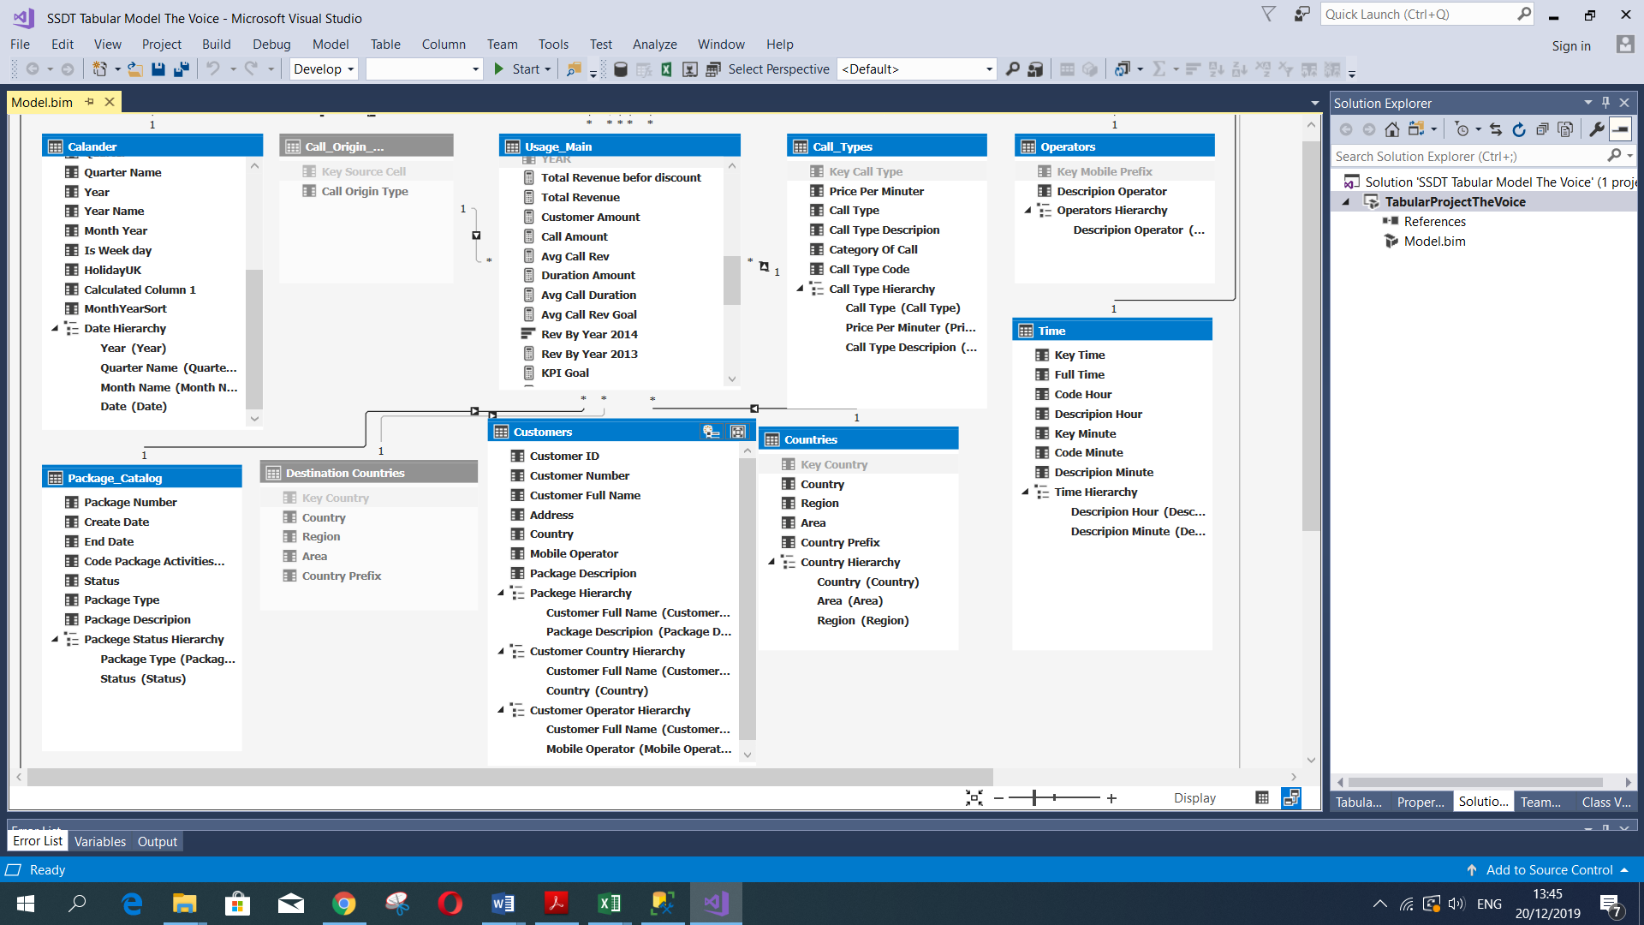

* We ensure that the data type and format is fit for each column.
* In order to be able to sort the dates by the calendar, we decided to sort the next column: month name by month, day name by day of the week, a quarter name by quarter, year name by year, month year by calculated column Month Year Sort
* We hide unnecessary columns from the end-user.
* We added calculated columns: Discount, Discount percentage, discount type.
* We defined measures based on the fact table, in order to use them on PBI.

Here are some of the measures:

* Call Amount – counting the unique call ID column
* Number of customers – count distinct of key customers column
* Duration Amount – Sum of duration column.
* Total Revenue – the sum of the billable duration column.
* Avg Call Revenue- Total Revenue divided Call Amount
* Call Duration Today- the amount of duration per day

**Dax**: *Call Duration Today:= CALCULATE(sum(Usage_Main[Duration]),FILTER(Calander,Calander[Date]= [Today]))*

* Call duration average – an average of duration column
* Total Revenue this week-

**Dax***: Total Rev This Week:= CALCULATE(sum(Usage Main[Billable Amount]) ,FILTER(Calander,Calander[Date]>= [Today]-7))*

* Total Revenue last week-

**Dax**: *Total Rev Last Week:= CALCULATE(sum(Usage_Main[Billable Amount]),FILTER(Calander,Calander[Date]<= [Today]-7),FILTER(Calander,Calander[Date]>=[Today]-14))*

* Today- because our data refers to the years 2013-2014, we forced to manipulate the function ‘Today’.

**Dax**: *Today:= TODAY() – 1822*

* Revenue by year-

**Dax**: *Rev By Year 2013:=SUMX(FILTER(Usage_Main, Usage_Main[YEAR]="2013"),Usage_Main[Billable Amount])*

* We defined three dynamic KPI’s: Revenue by year, Sales today and Call duration per day

**See ***chapter 8.1***.

In order to ensure the calculations are correct and verify the data, we used to export the usage main table to excel.

**See ***Excel for Tabular***file.

**7.1 Perspectives-**

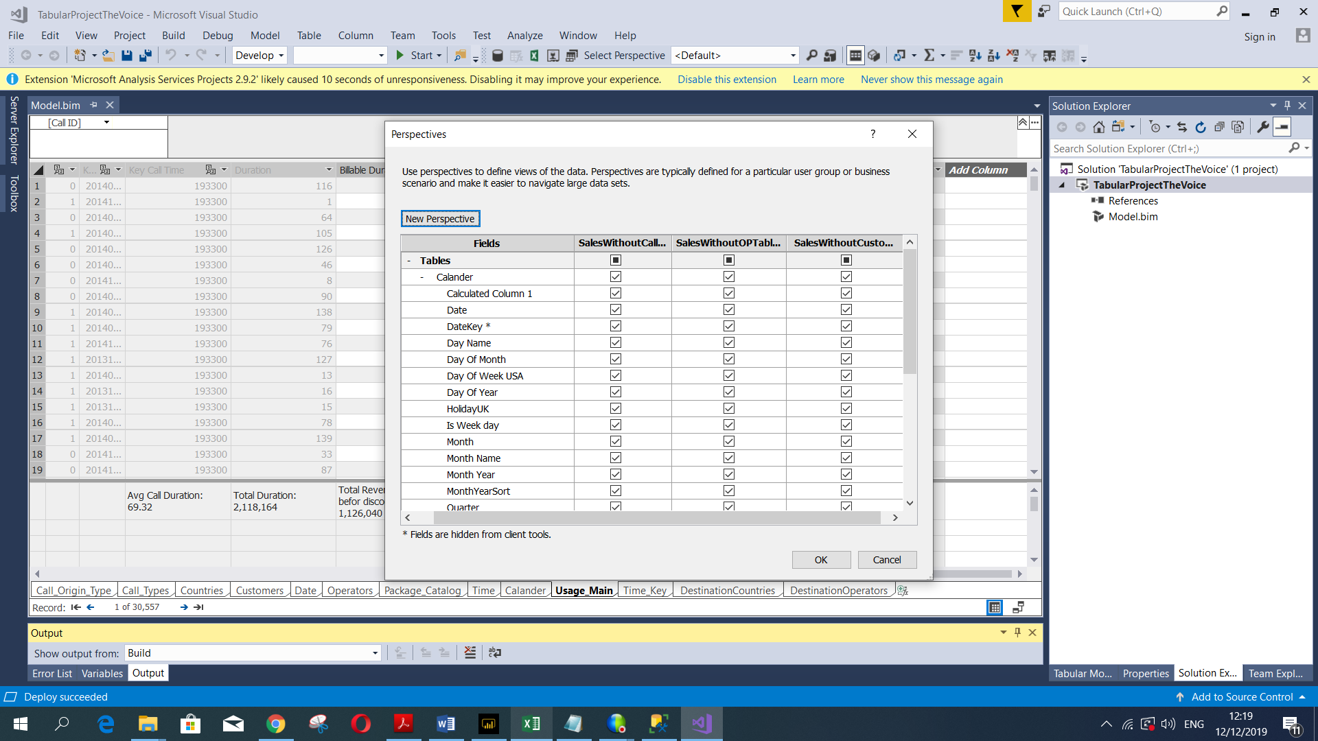We have Built 3 Perspectives, in order to manage the data for each user in PBI. Perspectives are used to provide suitable user experience, not a security mechanism.

1. Sales Without Call Type:

All tables are shown to the user in PBI, except columns: call type code, call type description, category of call and key call type in Call Type Table.

1. Sales Without Operational Tables:

We remove the operational table such as Date, Time and Time Key.

1. Sales Without Customers:

All tables are shown to the user in PBI, except columns: address, country, customer number, and customer id.

**7.2 Hierarchy-**

In order to improve the ability to drill down in PBI reports and visualizations, we create 9 hierarchies.

* Country Hierarchy; Area and Region
* Date Hierarchy; Year, Quarter Name, Month Name, and Date.
* Time Hierarchy; Description Hours and Description Minute.
* Package Hierarchy; Customer Full Name and Package Description.
* Customer Country Hierarchy; Customer Full Name and Country.
* Customer Operator Hierarchy; Customer Full Name and Mobile Operator.
* Call Type Hierarchy; Call Origin Type.
* Package Catalog Hierarchy; Package Type, Status.
* Operator Hierarchy; Description Operator.

**Partitions**-

we have created a partition in this stage, in order to divide the process into a smaller and better loading of the operational DB. The Partition is:

* Sales 2013, using the following SQL statement:

select *, LEFT ([Key Call Date],4) as 'YEAR'

from

Fact_Usage_Main

where LEFT ([Key Call Date],4) LIKE '2013'

* Sales 2014, using the following SQL statement:

select *, LEFT ([Key Call Date],4) as 'YEAR'

from

Fact_Usage_Main

where LEFT ([Key Call Date],4) LIKE '2014'

**7.3 Roles-**

We have created rolls to 3 different users, in order to give them permissions according to their job description in ‘The Voice’ Company.

* Call Type Manager- This manager called Doron, has only Read permission in PBI reports and can see only Voice Call Type.
* Israel Manager- This manager called Liat, has only Read permission in PBI reports and can see only calls made from Israel.
* Call Type Manager- This manager called Michael, has only Read permission in PBI reports and can see only calls made from the United States.

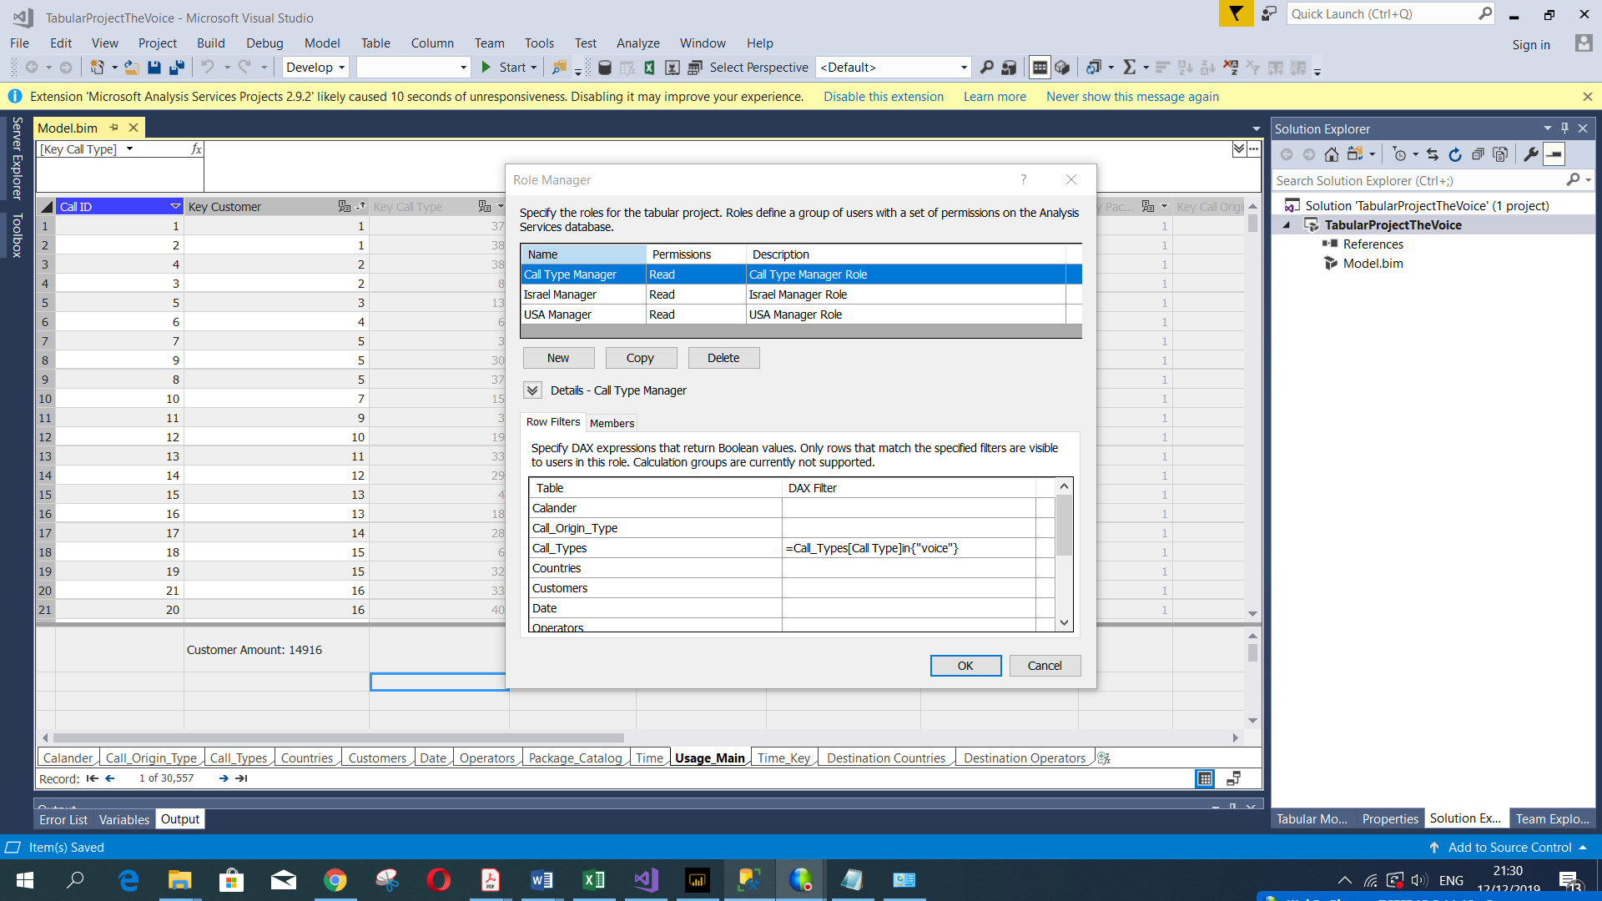

**7.4 Deploy Model from Tabular-**

We have made a deployment from the tabular model to analysis services, in order to update our tabular scheme.

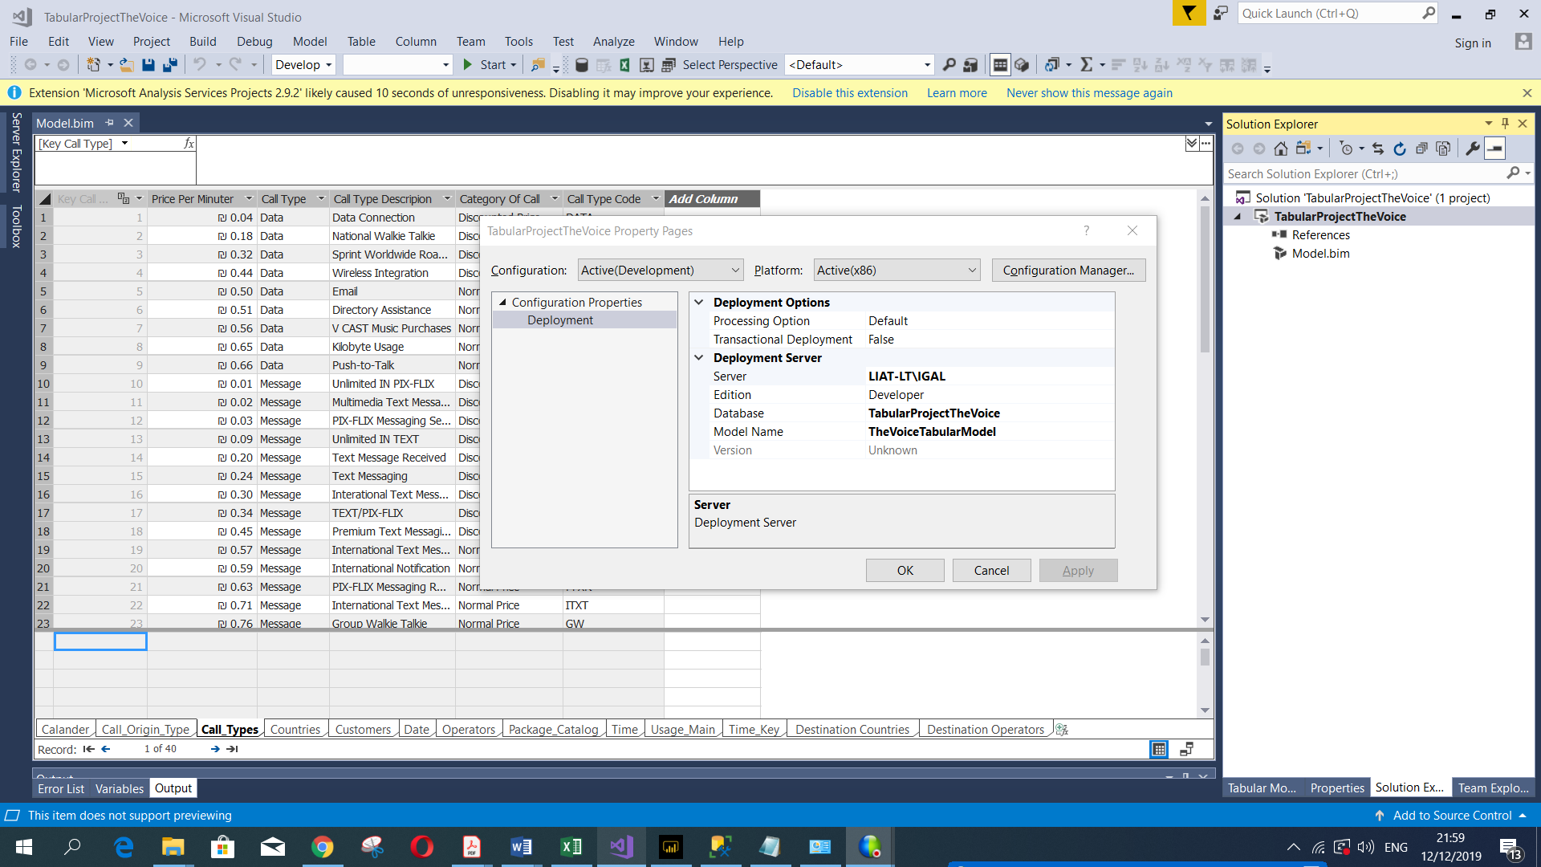

**7.5 Process-**

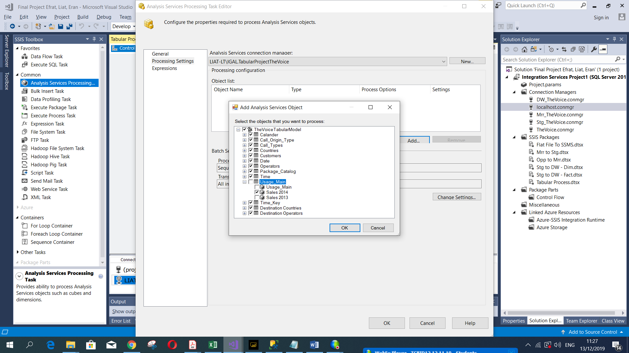We have created a Full Process in SSIS by adding a new package. and added a job with schedules in SSMS.

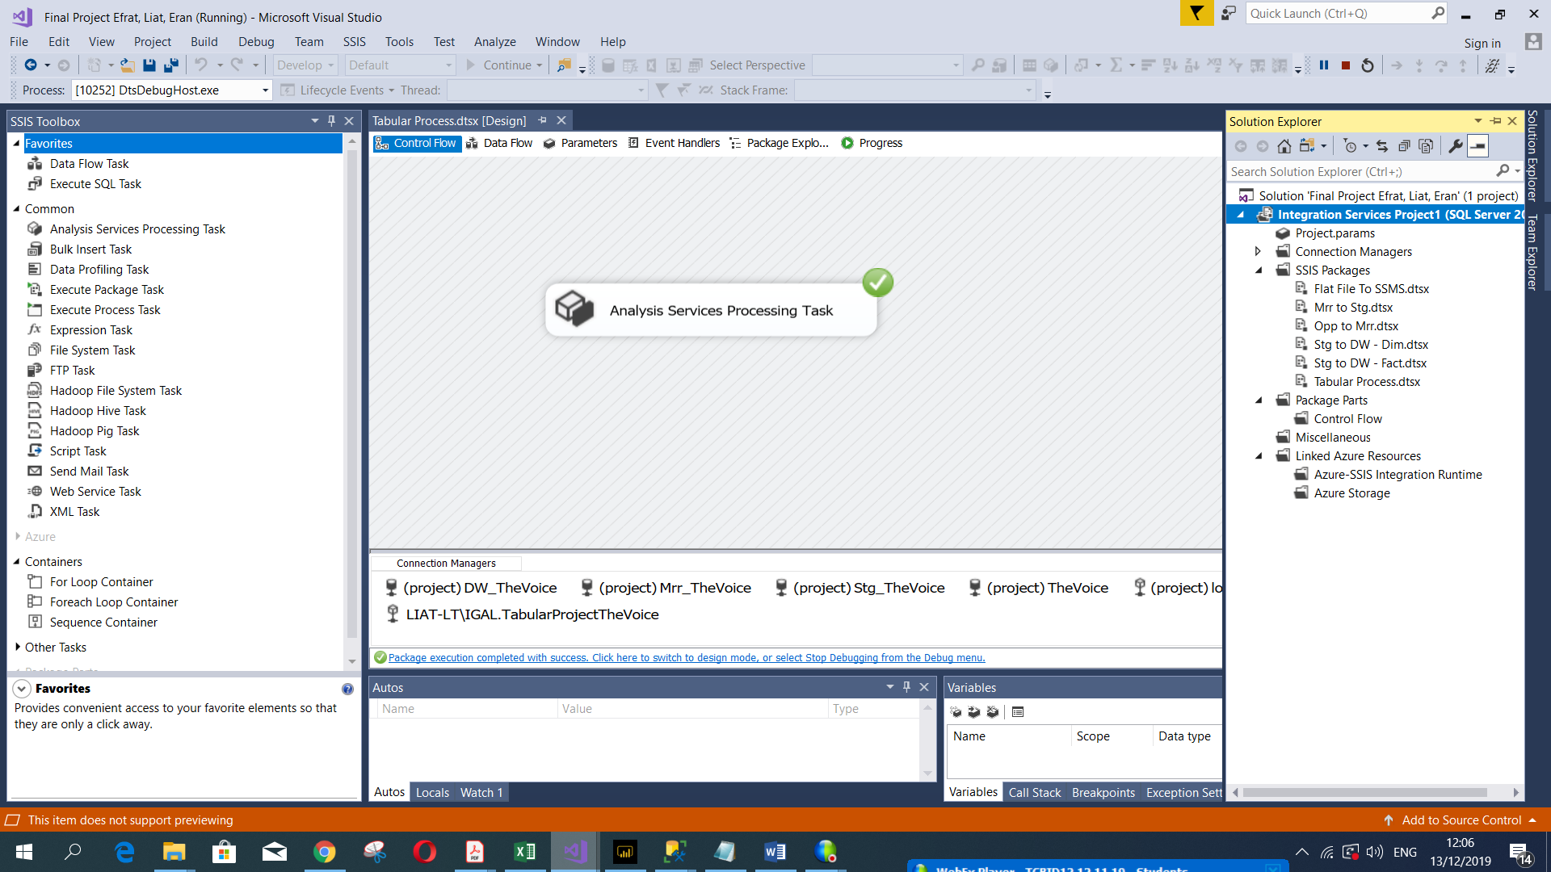

**Power BI Desktop**

In this part, we use Power BI Desktop, in order to create a visualizations tool based on the DW of the company that built so far. We connect live to the Tabular Model Database in Analysis Services Server, which we create in the previous part, and got our data.

**8.1 KPI -**

This tool helps us evaluate the company's economic goals. For example; In order to evaluate the company's economic growth, we analyzed the revenue in 2014 and set a goal of the total revenue in 2013 + 20% growth. By using a dynamic target measure.

1. Revenue By Year 2014:

* Value- Revenue In 2014
* Target Goal- Revenue 2013 + 20%

1. Sales Today:

* Value- Total Rev Per Day
* Target- Avg Rev Per Day + 20%

1. Call Duration Per Day

* Value- Sum Of Call Duration Per Day
* Target- Avg Duration Per Day + 20%

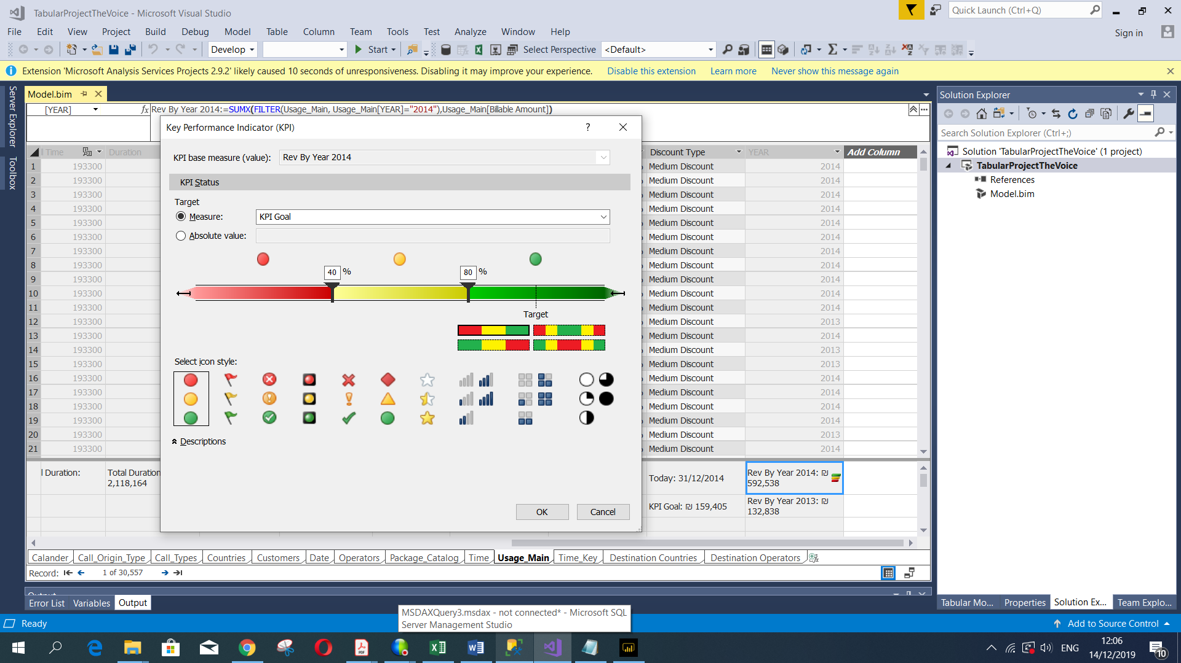

**8.2 Power BI Dashboard and Functions -**

We implement function and visualizations in Power BI Desktop, In order to give the user or analyst the best economic decision-making based on the data. Data-Driven Organizations use this visualization tool and make a decision every day based on different dashboards that we as developers built.

Our eight dashboards built in order to give the managers or analysts in The Voice company, a number of perspectives on the company in different periods of time.

We used Filters (visual, page and report), Interactions, Drills, Measures, What If the parameter (because we connect live to the tabular model in PBI, we required to create a parameter table in order to build the What If parameter) and costume tooltip.

In each dashboard, we used all the tools we gain throwout our studies.

The Daily Dashboard for example:

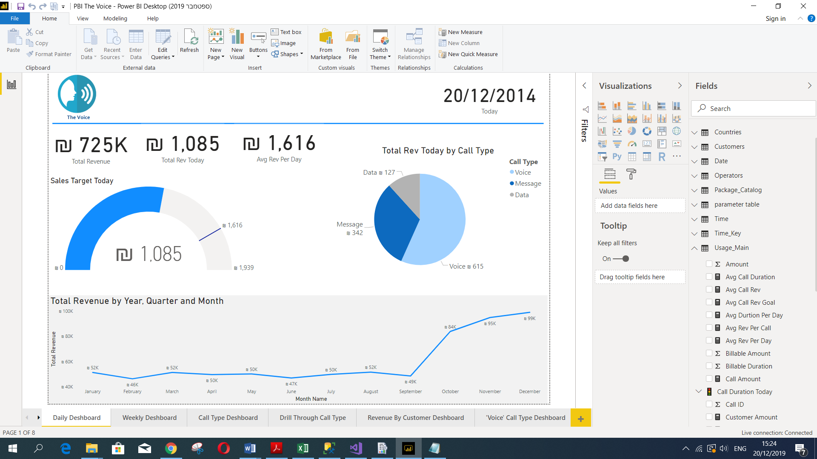That dashboard presents real-time data on a certain day.and We can see if the company made the target sale for the day.

Call Type Dashboard for example:

In this Dashboard, that presents data on the call Types in the company, we also can Drill Through another dashboard ‘Drill Through Call Type’ with initial data.

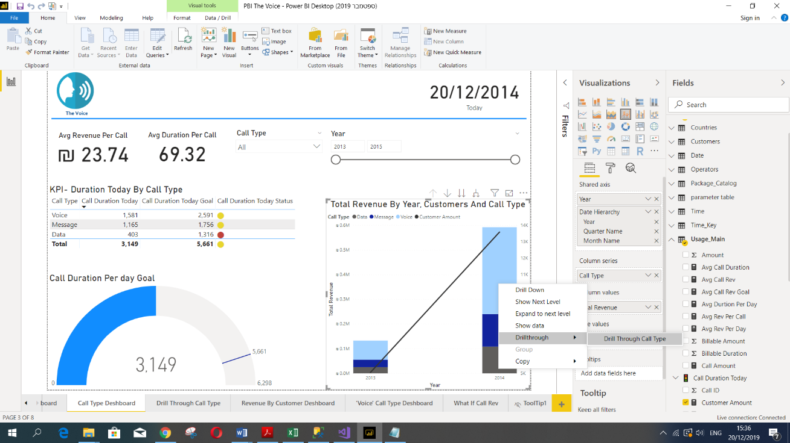

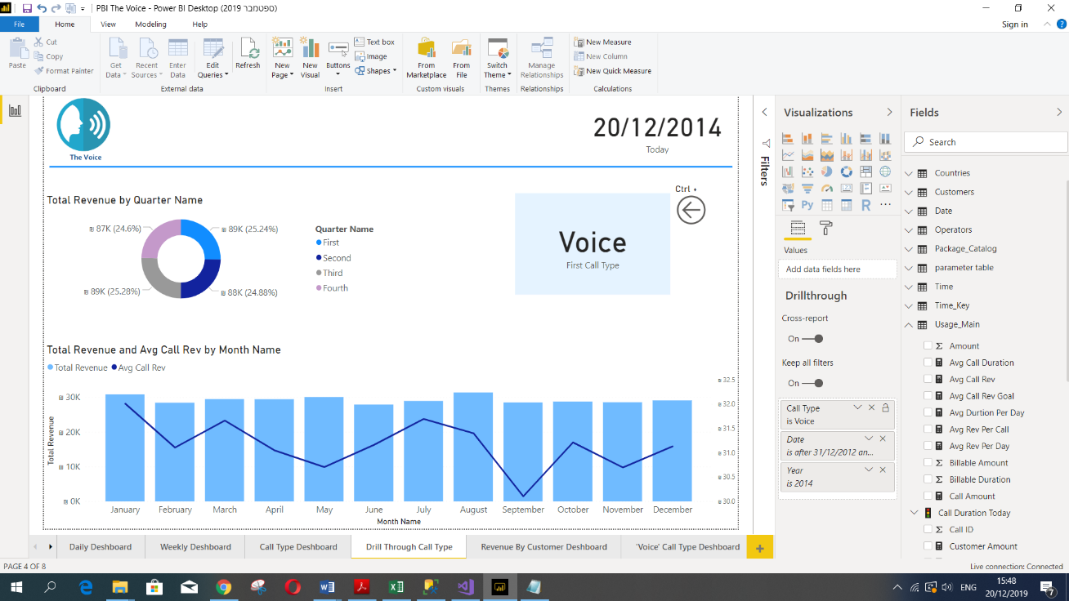

**8.3 Deploy to Power BI Report Server (on premise)-**

We can see below all dashboards in Power BI Report Server, after uploading the Power BI Desktop file.

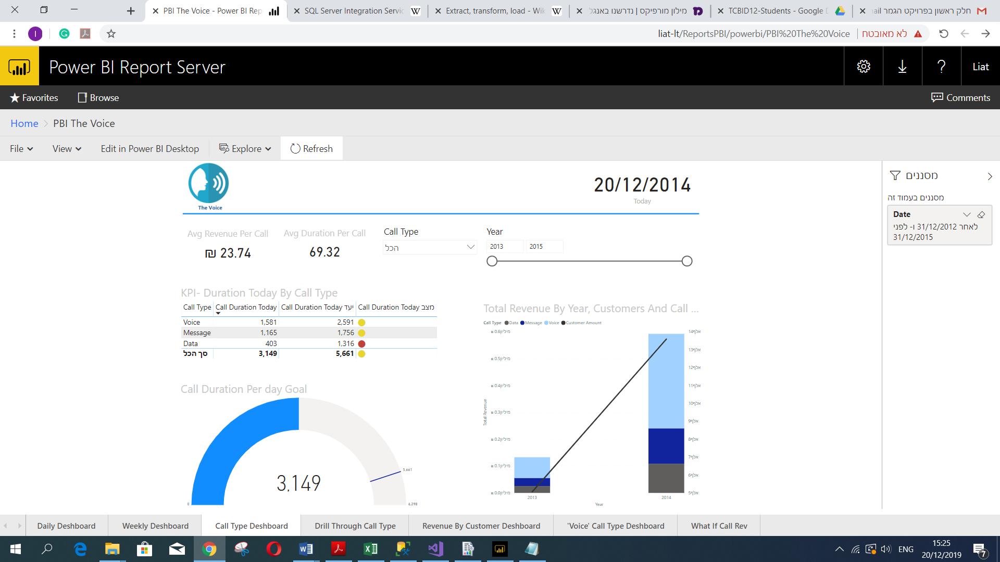

**DAX Studio**

This chapter will demonstrate some query skills on DAX language in the DAX studio tool. The quarries based on logical business needs.

**See ***Dax The Voice*** attached.

1. Adding a column to usage main table from counties table

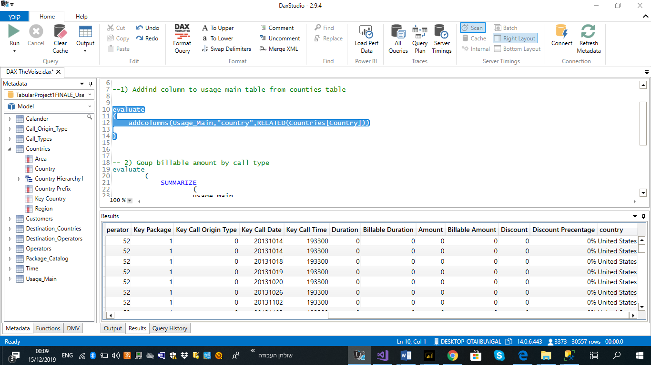

1. Group billable amount by call type

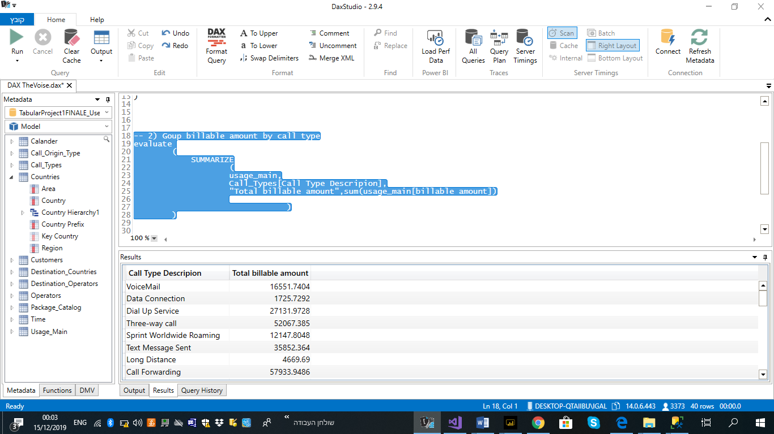

1. Shows only countries in region 'Americas'

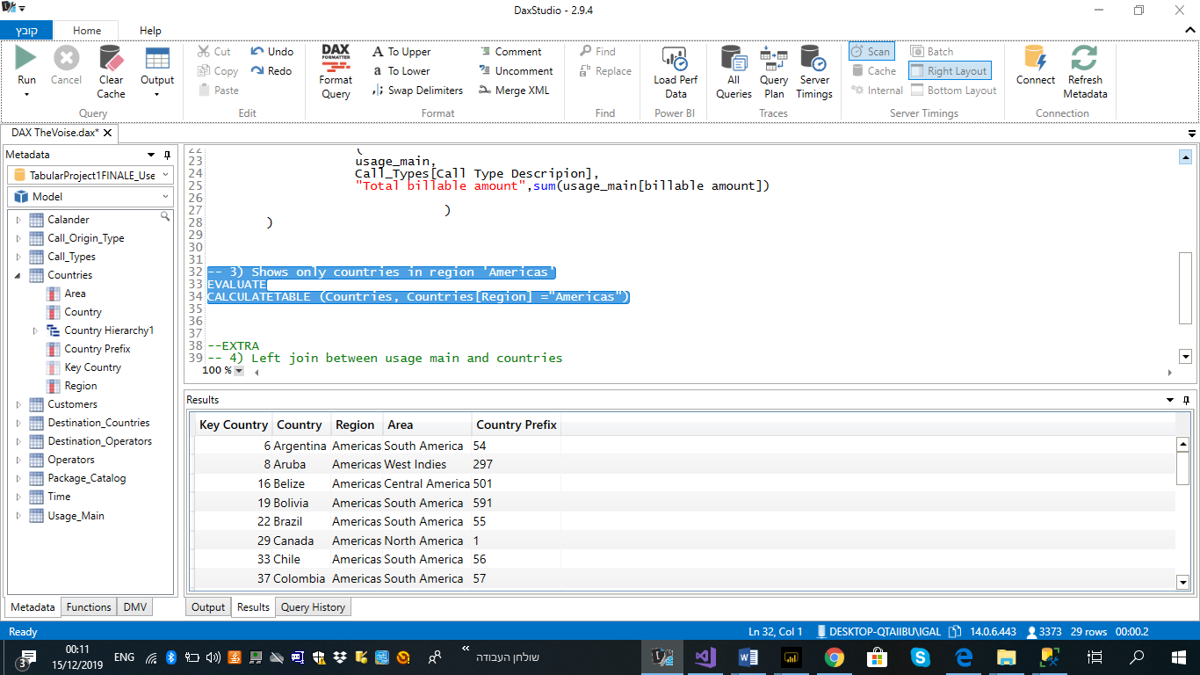

1. Left join between usage main and countries

